Wicklander-Zulawski
Instructor Training Documentation
Thomas M. Manson
2018

Table of Contents
Overview 3
Public Side – W-Z.com 3
Public Side – Training Schedule 4
Public Side – Training Schedule – Geographic View 4
Public Side – Registration Page 5
Administrative Side (Administrative Backend / Courses View) 6
Instructor Side (Instructor Profile / Past Classes Tab) 7
Instructor Login 8
Lost Your Password? 8
Instructor Profile 9
Account Information 9
Current Classes Tab 10
Edit Travel Information 11
View Travel Doc 13
Taking Class Attendance (Attendance Button) 15
Sign In 16
Walk In Registration 17
Closing a Class (Close Class Button) 18
Location Intelligence 19
After Action Review 20
Reimbursements 21
AAR Questions 21
Logging Out of the System 22
Past Classes Tab 23
Viewing Evaluations 24
Public Side Evaluations 25
Course Materials Tab 27
Example 1 – Pre-Class Materials 27
Example 2 – Post-Class Materials 27
Notes about Course Materials 28
Guiding Questions to ask PRIOR to uploading documents to Course Materials 28
Adding Course Materials 29
Deleting Course Materials 29
Schedule 30

Overview
This documentation will provide WZ Instructors with the tools to fully utilize the Instructors Administrative pages (WZ Instructors Backend) by logging into the backend portal.
WZ’s software solution involves 3 different interface sides: Public side (the website), Administrative Backend, and the Instructor Profile. Data/information input from each of these 3 sides can impact and effect the other sides. All 3 sides of the solution work together in various ways, serving as input locations and sharing points for information.
For example, WZ office staff can create a training course (via the Administrative Backend) which includes, host, location, and other information. This training course then appears on the Public Side, allowing for students to create registrations. Portions of these registrations are then viewable by the Instructor (via the Instructor’s Profile).
The general purpose of this document is to explain the role of Instructors in the overall process, and to provide specific steps for instructors to engage and effectively utilize the system.

Public Side – W-Z.com
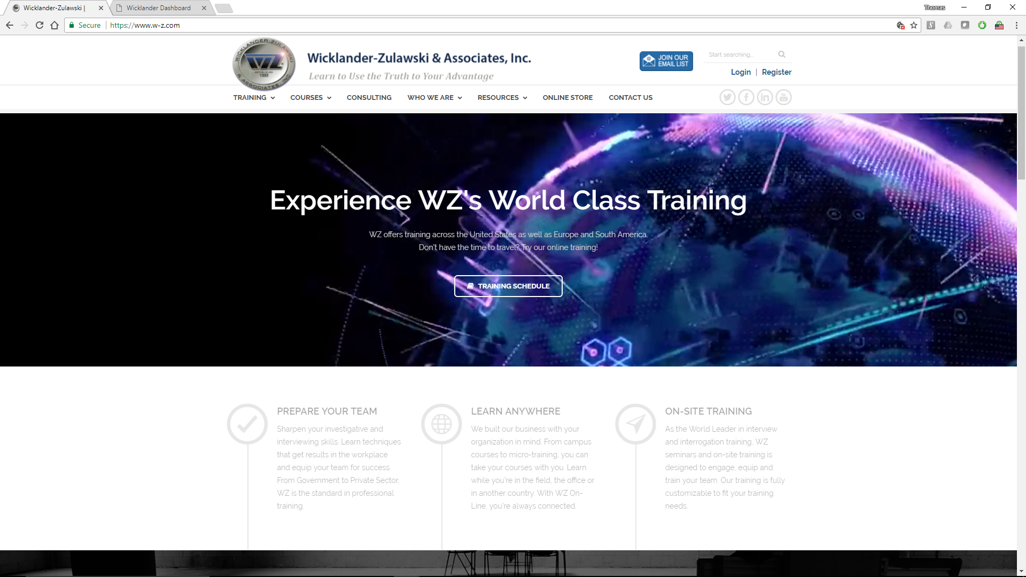
The primary website of Wicklander-Zulawski & Associates launched in 2017, public interface for taking registrations; login point for Administrative and Instructor sides.

Public Side – Training Schedule
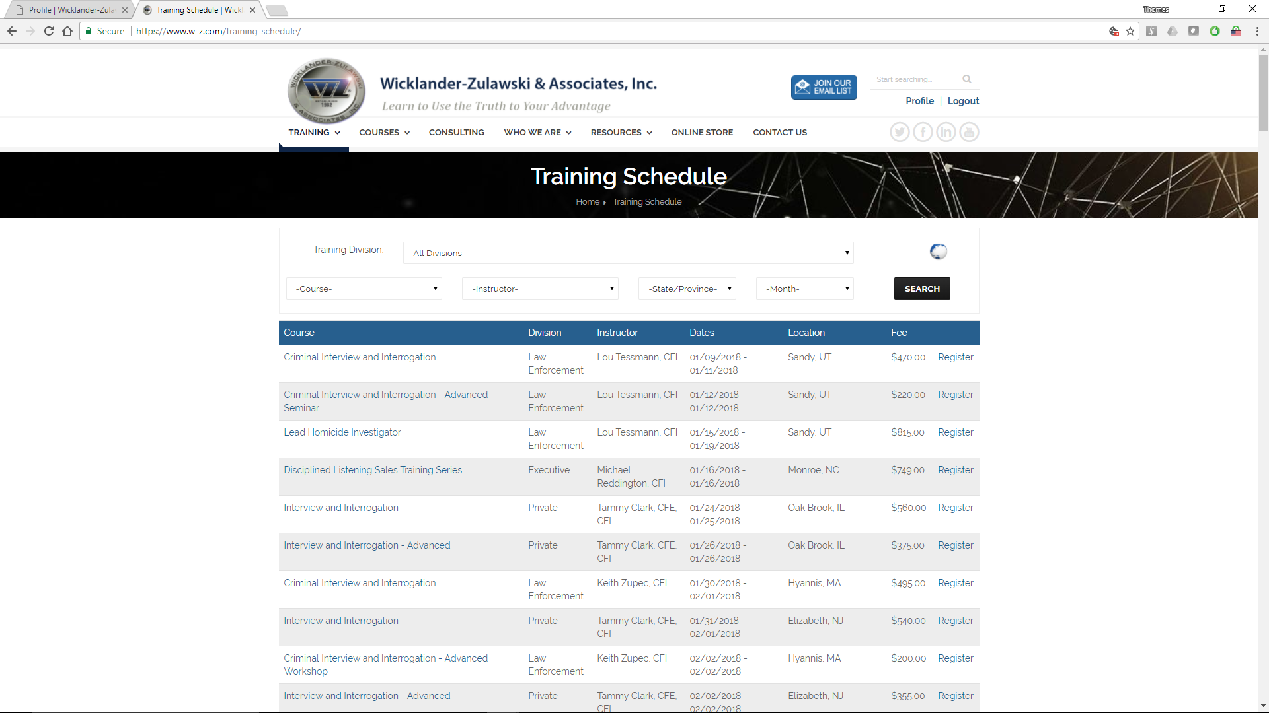
Training Schedule and Training Map
Both pages are searchable interfaces for training classes and avenue for obtaining student registrations.

Public Side – Training Schedule – Geographic View
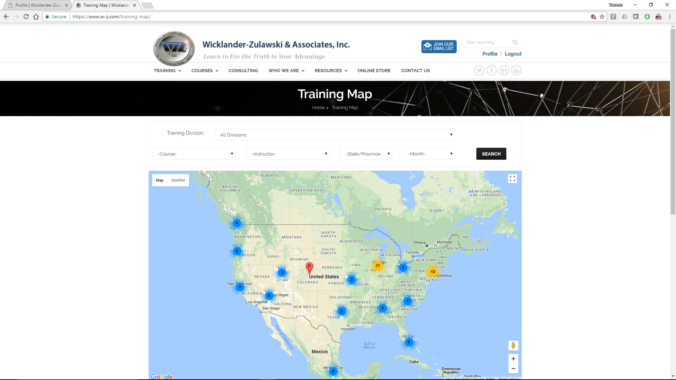

Public Side – Registration Page
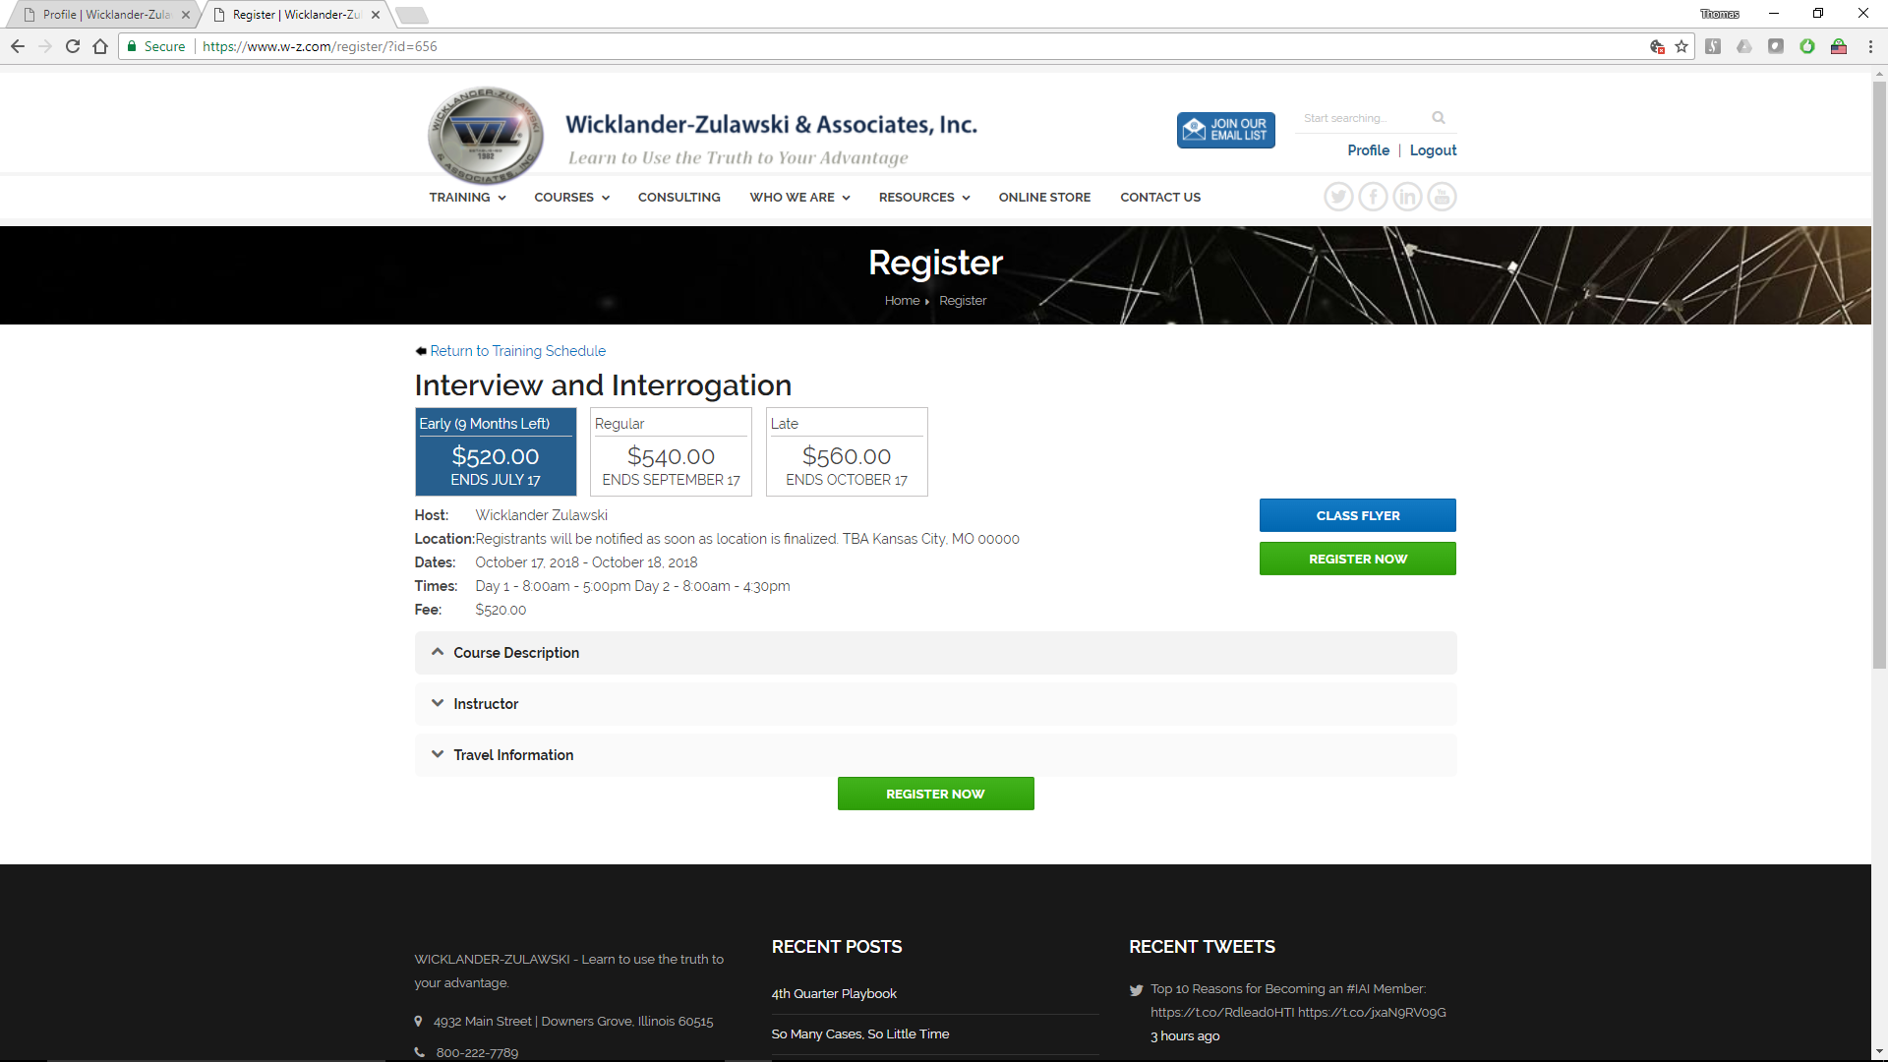
First page of standard W-Z.com registration page. Includes: Title, Pricing, and general information. Also includes drop downs for additional Course, Instructor, and Travel Information and direct Registration links (Register Now buttons).

Administrative Side (Administrative Backend / Courses View)
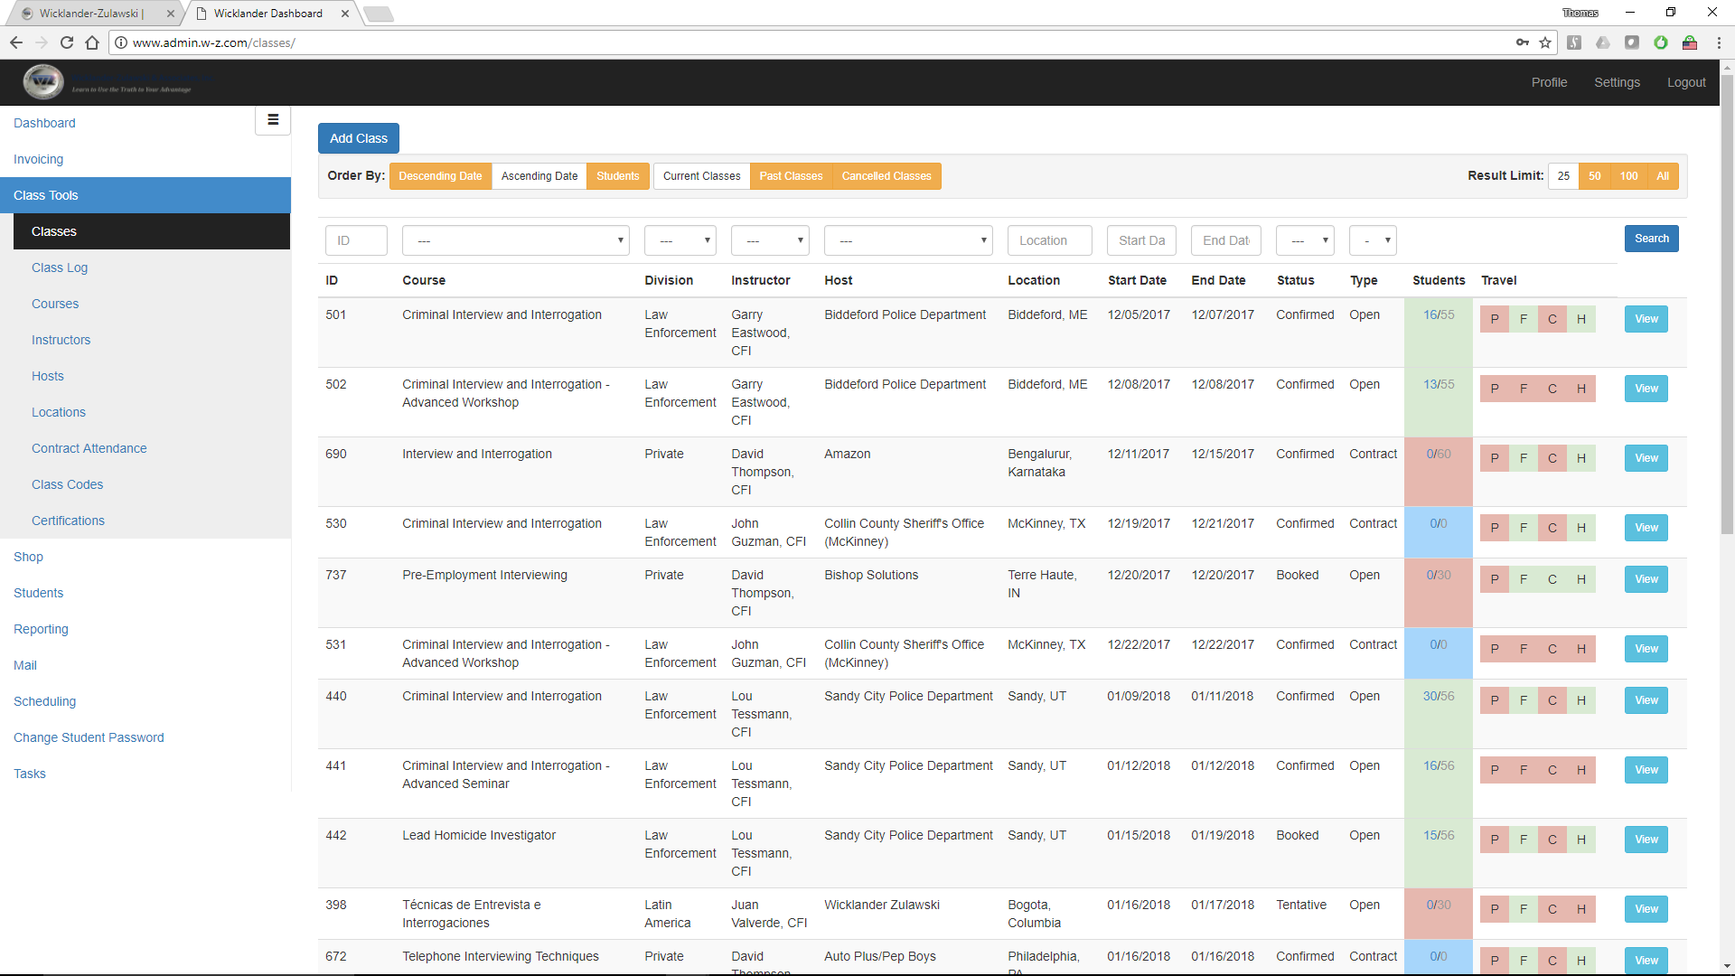
Administrative Backend / Courses View shows multiple, color-coded, scheduled courses.

Visible from this searchable interface include:
- Course and Host Information
- Status of Courses (Tentative, Booked, Confirmed)
- Type of Course (Open, Contract)
- Numbers of Students – Currently Registered
- Travel Information
  - Package Notes
  - Flight
  - Car
  - Hotel

Instructor Side (Instructor Profile / Past Classes Tab)
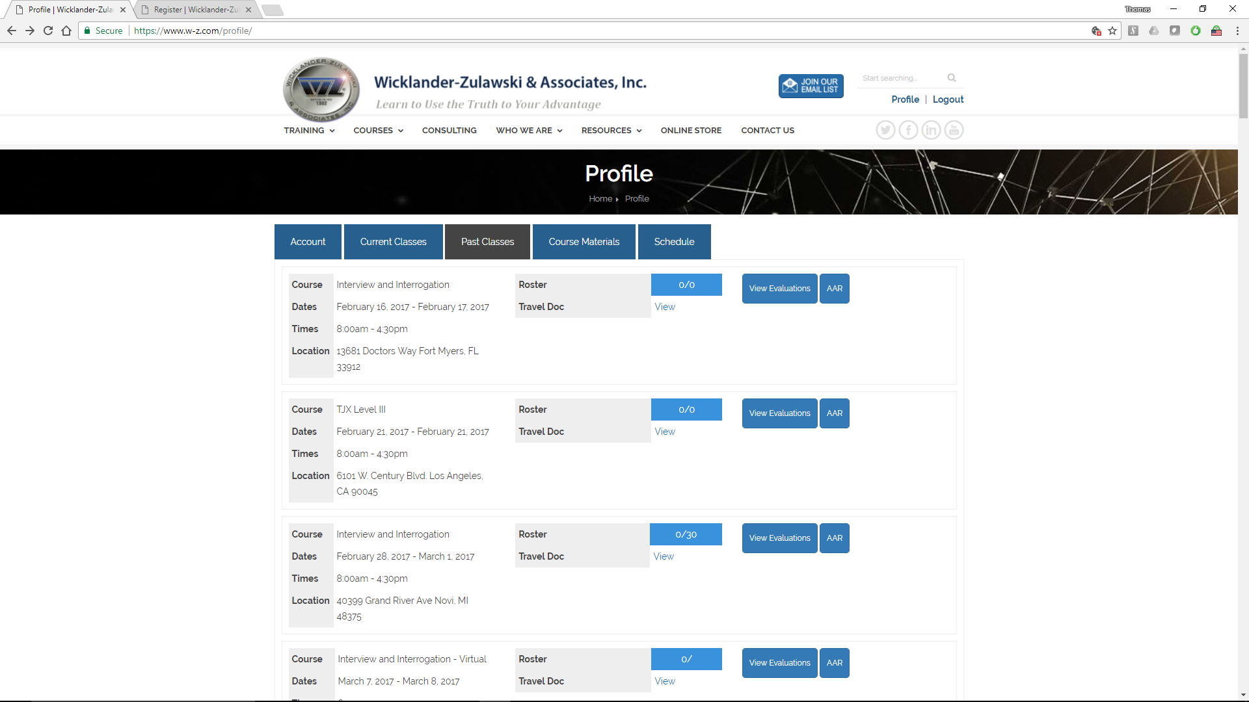
Instructor Profile / Past Classes Tab shows) shows previously taught courses.
Visible from this interface are:
- Courses taught by the Instructor in reverse Chronological Order (most recent at the top)
  - General Course Information (Title, Dates and Times, location)
  - Roster (of Students)
  - Travel Documentation
  - Evaluations (by Students)
  - After Action Review (AAR)

Instructor Login
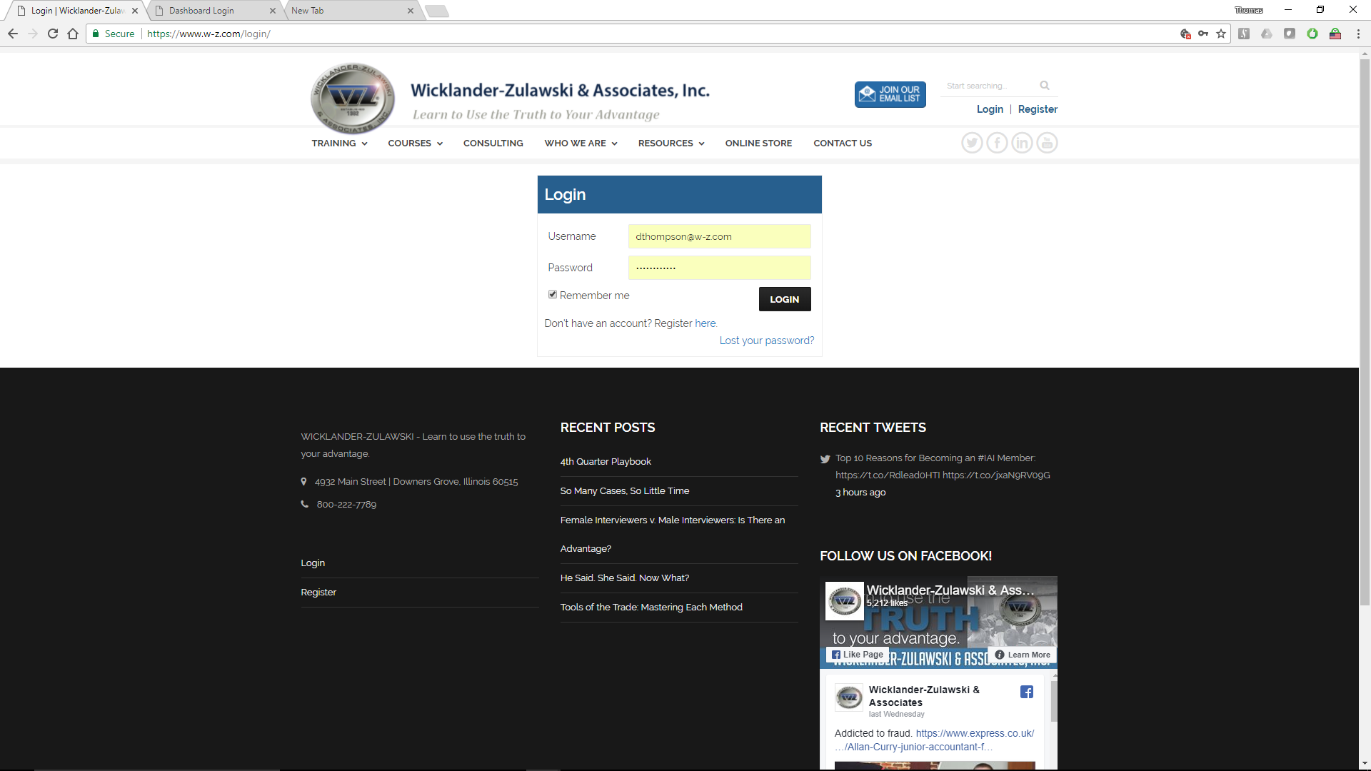
Instructors login into their Instructor Profile from http://www.w-z.com.
User Name and Password are required and will typically require W-Z authorized email addresses and complex passwords for access.

Lost Your Password?
Password may be reset using the Lost Your Password feature located at the bottom of the Login box.

Instructor Profile
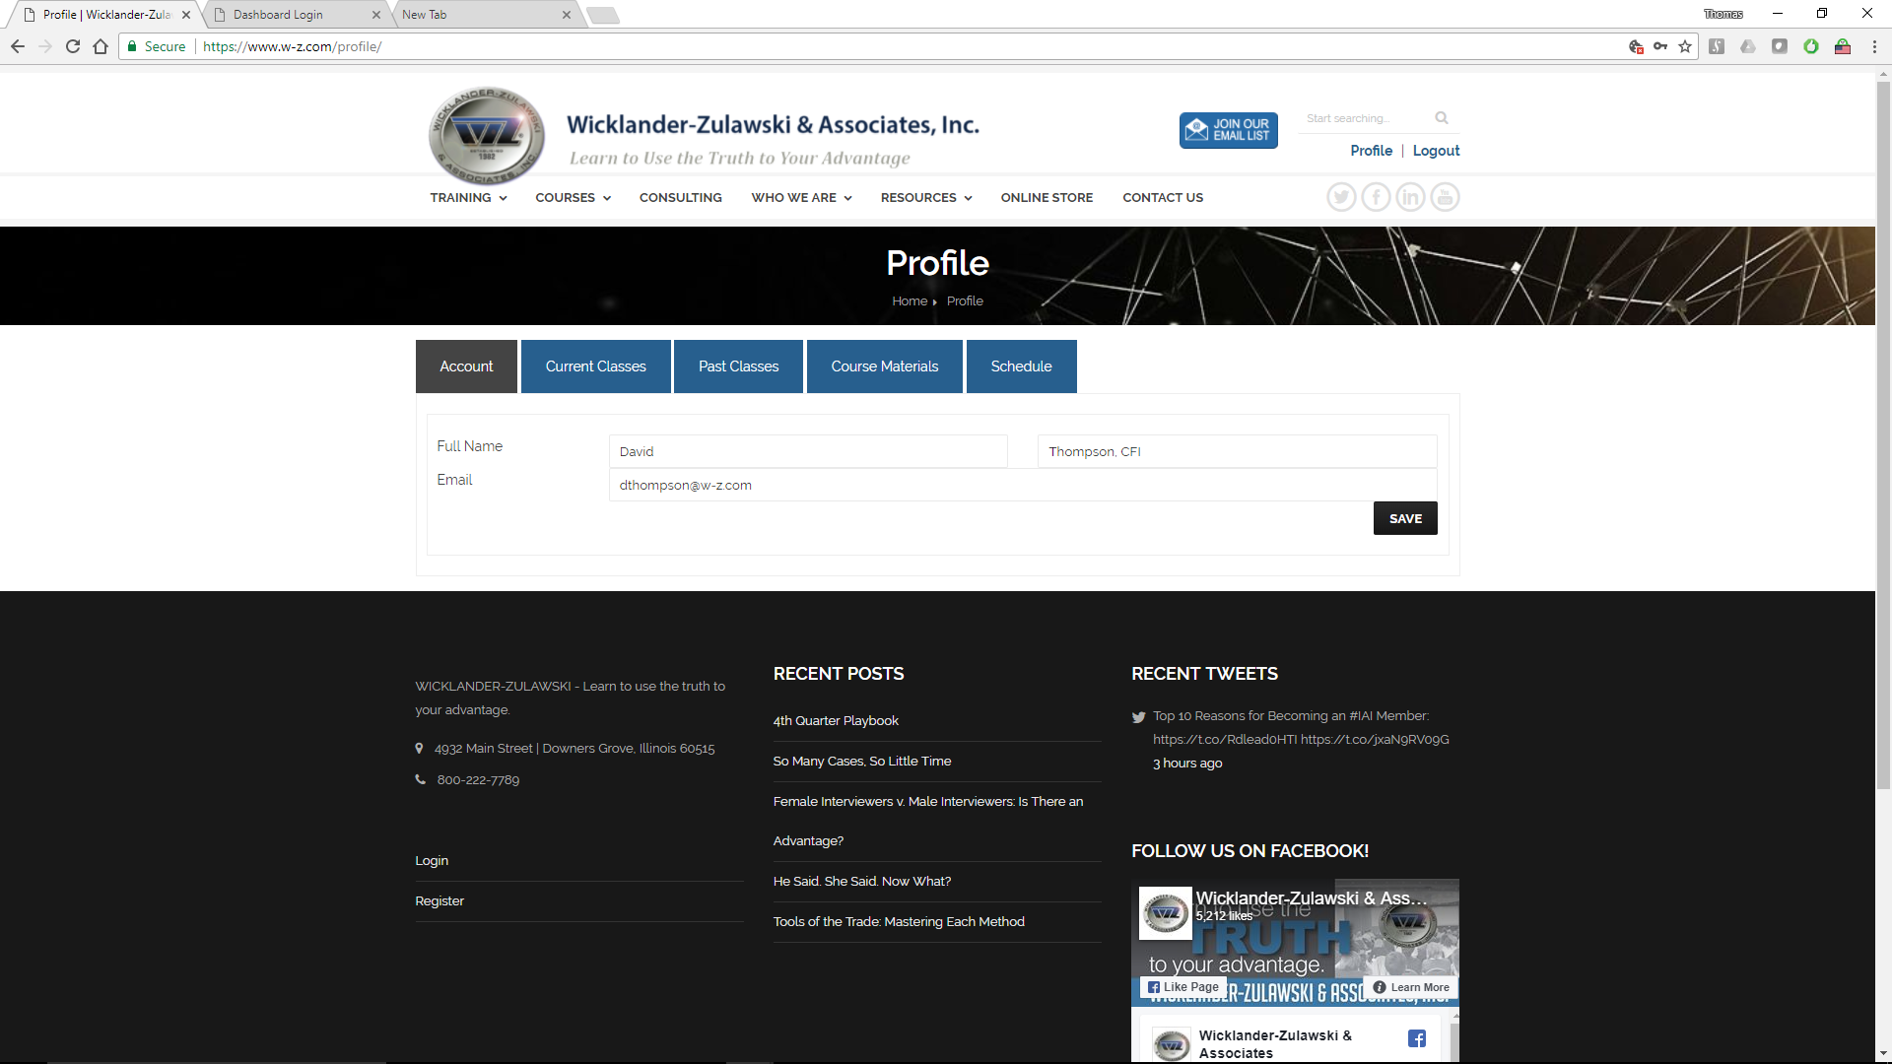
Once logged in Instructors have access to a simple 5-tab interface, the Instructors Profile.
From this screen instructors can view their:
- Account information
- Current Classes
- Past Classes
- Course Materials
- Schedule

Account Information
This button simply shows the Account Holder’s name and email address.

Current Classes Tab
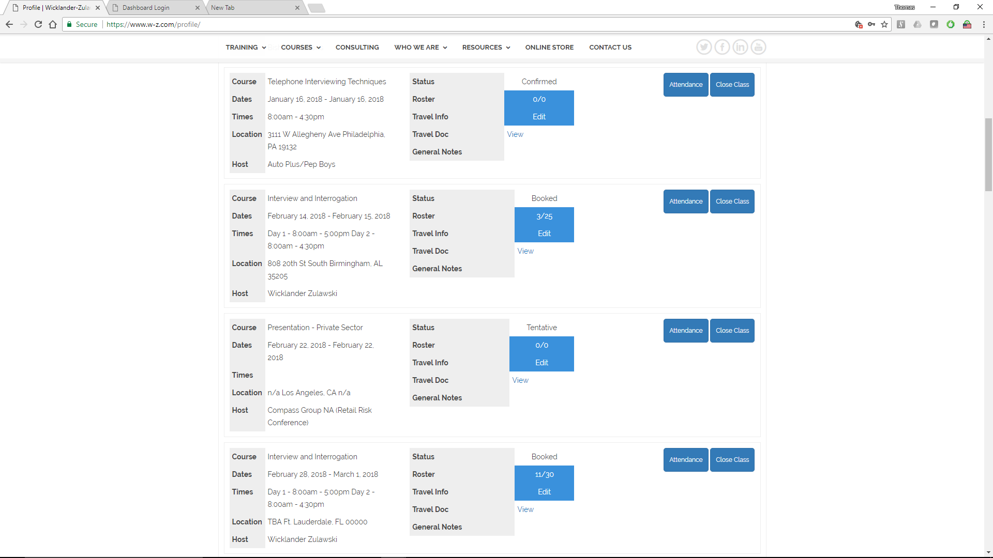
The Current Classes tab shows a list of all of the scheduled courses for the logged in Instructor.
From this view each course is listed, showing:
- General Course Information
- Course Status (Tentative, Booked, Confirmed)
- Roster (of Students)
- Travel Information (both editable and printable)

Also, accessible for each class are the buttons:
- Attendance
- Close Class

Edit Travel Information
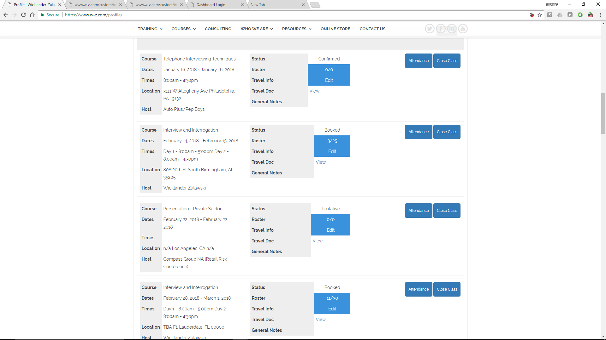
Each Current Class has a Travel Information section. This section can be accessed BOTH by WZ Administrators and by Instructors (each via the Administrative Backend or the Instructor Profile respectively).
Instructors can edit their own travel documentation by clicking on Edit from any course.

From this view Instructors can ADD, EDIT and VIEW financial and general information about Flights, Rental Cars, and Hotels. Information in these sections can be accessed BOTH by WZ Administrators and by Instructors.

Example: If an instructor has made their own flight arrangements, that information can be copied by the instructor into the Flight Information section so it is accessible by all WZ personnel. This is the sole location for this type of information.
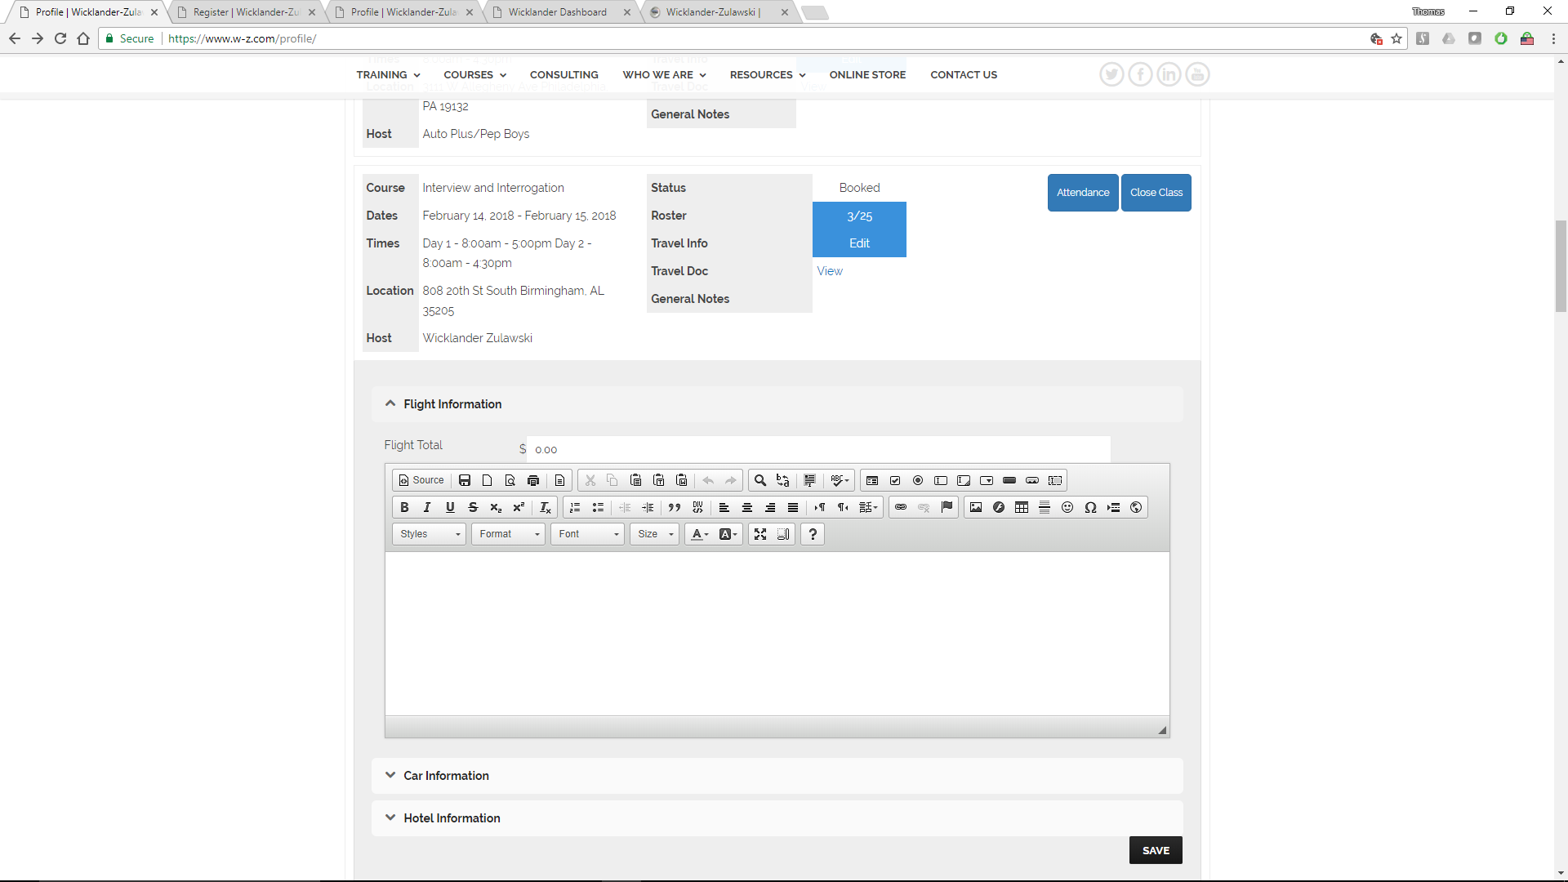
Once this flight information is added, a color change occurs (green showing that the field has data, red if it is empty) for WZ Administrative personnel showing that an instructor’s flight has been purchased and confirmed. The Car and Hotel fields work similarly.

View Travel Doc
Instructors can View (and Print) their own travel documentation by clicking on View from any course.

This view will provide a printable copy of all of the relevant course data, an example is split below.
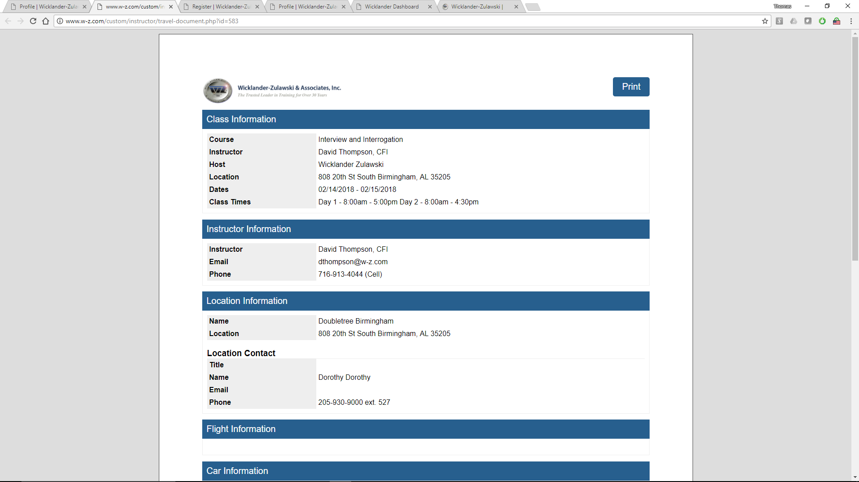

Product Pre-Orders (from students) are also included on this printable form
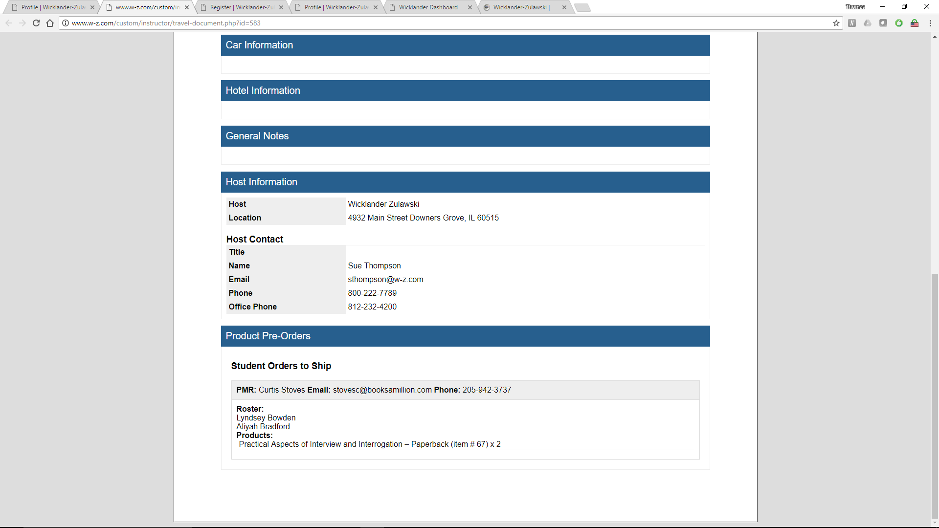

Taking Class Attendance (Attendance Button)
Attendance can be taken for any class (during the first day of the class). This is done by clicking the Attendance button. This will bring up the Attendance window. It shows the class information, allows for Walk-in Students (see below), and allows for students to Sign-in (to verify their attendance).
This process was designed to work with a tablet interface.

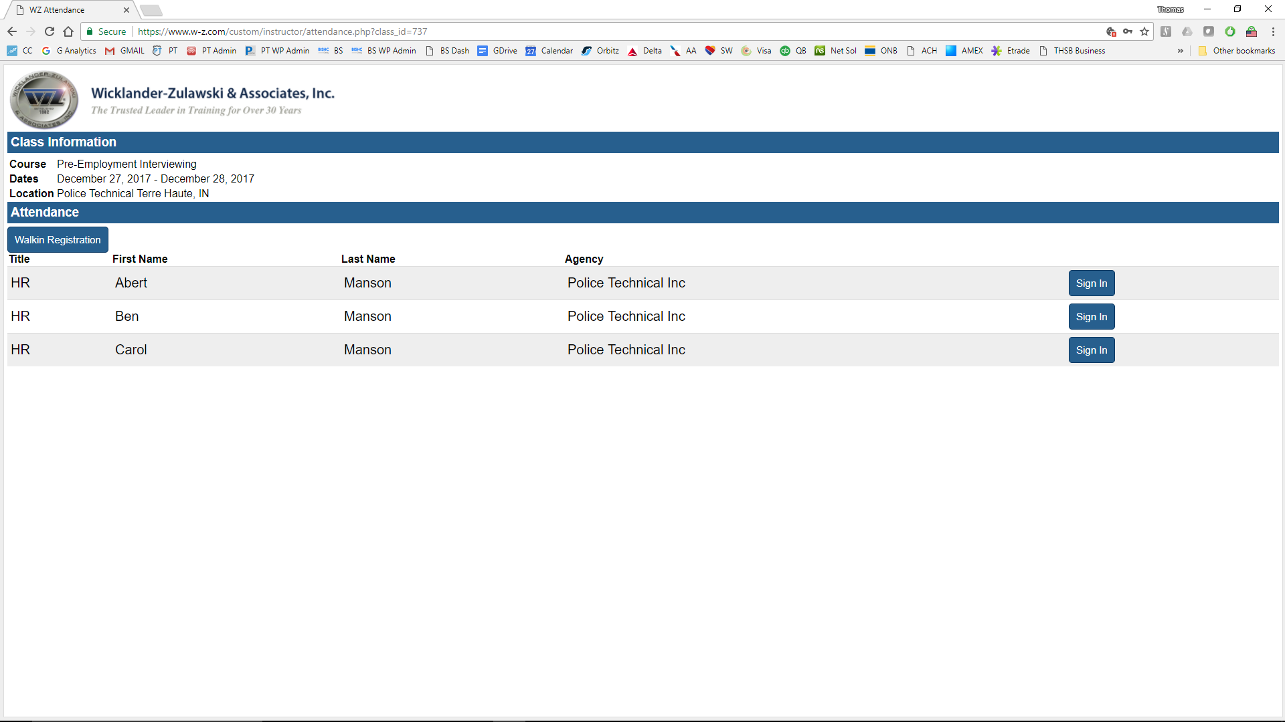
Students can find their name from the alphabetized list (by first name) and click Sign In.

Sign In
After clicking the Sign In button, students are taken to the Student Information screen, which shows their Title, Name (First and Last), Email and Agency. The bottom of the form provides a place for students to write their signature. After signing in, students may Save or Clear (to re-write their signature).

Students may also correct any information on this form, example: Misspelled names or incorrect email addresses.
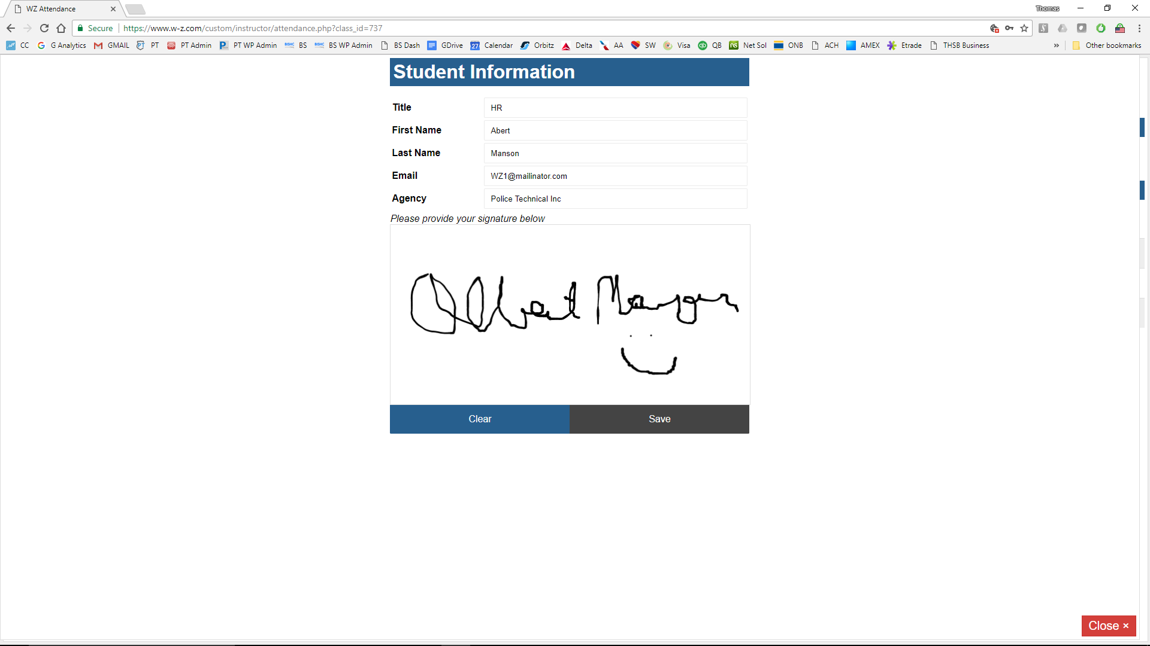

Walk In Registration
Pressing the Walk In button allows for students or instructors to quickly register for the class, taking them to the registration page for the class in question.

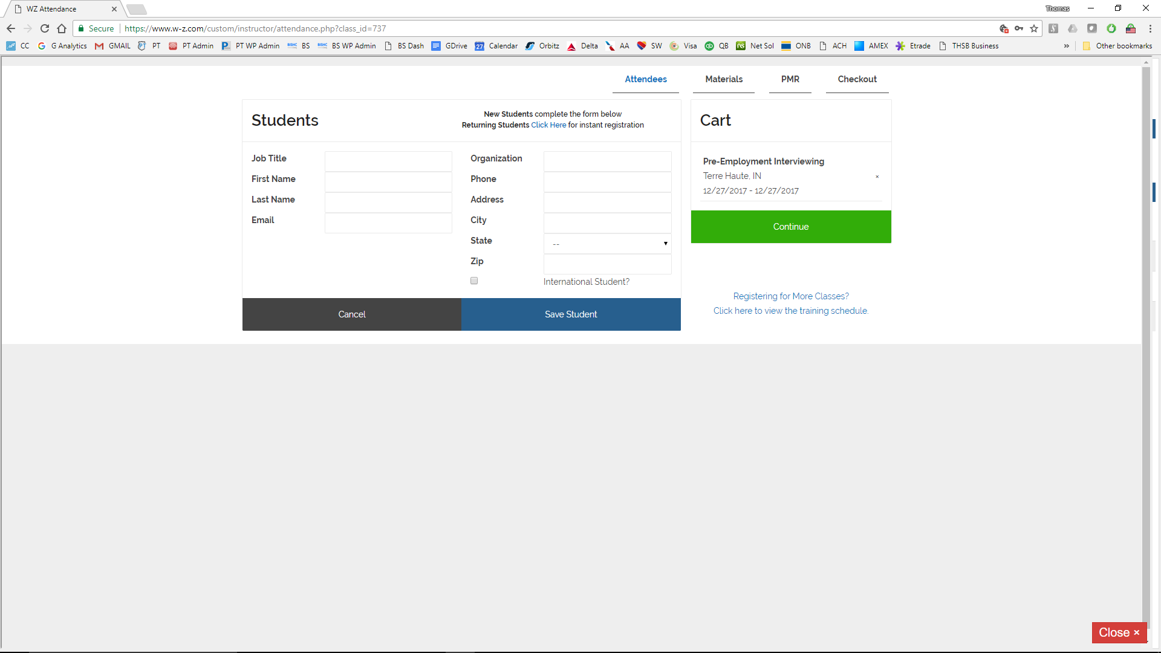

Closing a Class (Close Class Button)
A class may be closed any time after noon (12:00pm) of the last scheduled day, by clicking the Close Class button from the list of classes in the Instructor’s profile (1st image below)
In the example below, only two people signed in, and therefore only two names appear on the Student List. All signed in students by default are “pre-checked” as having completed the class. Instructors have the ability to “un-select” students who either did not attend or otherwise did not complete the course of instruction. Note: Student whose names have been “unselected” will not receive a Course Completion confirmation email, certificate and evaluation links. They will not be contacted via the automated email process at the end of a class.
Students whose names remained checked will receive an email from WZ, thanking them for their attendance and guiding them to complete an online evaluation.
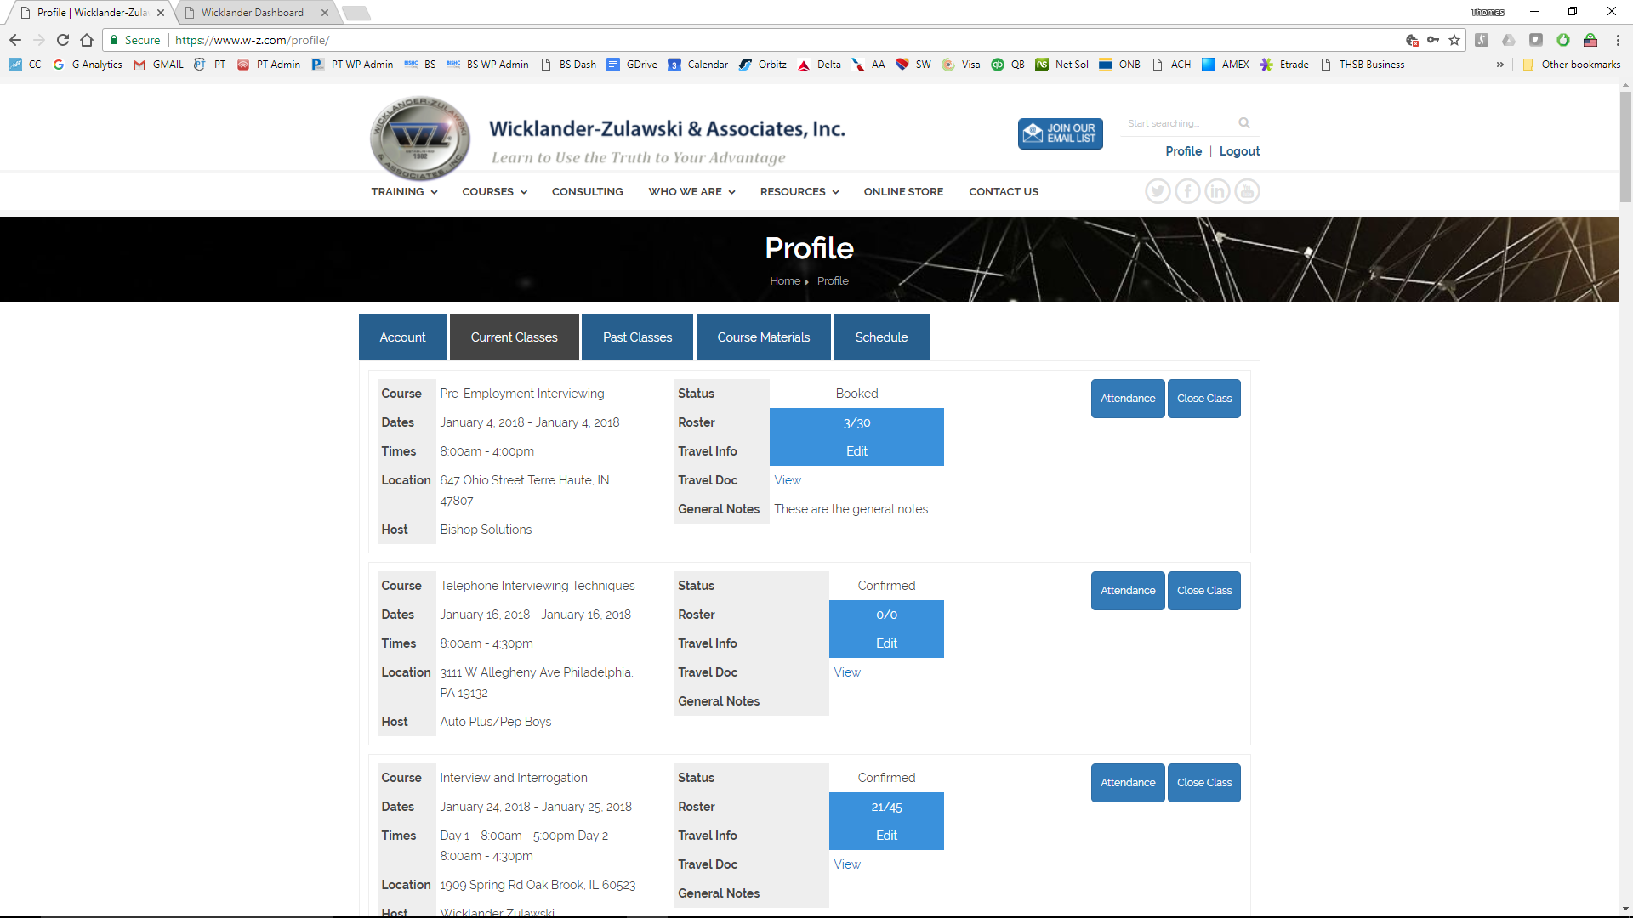
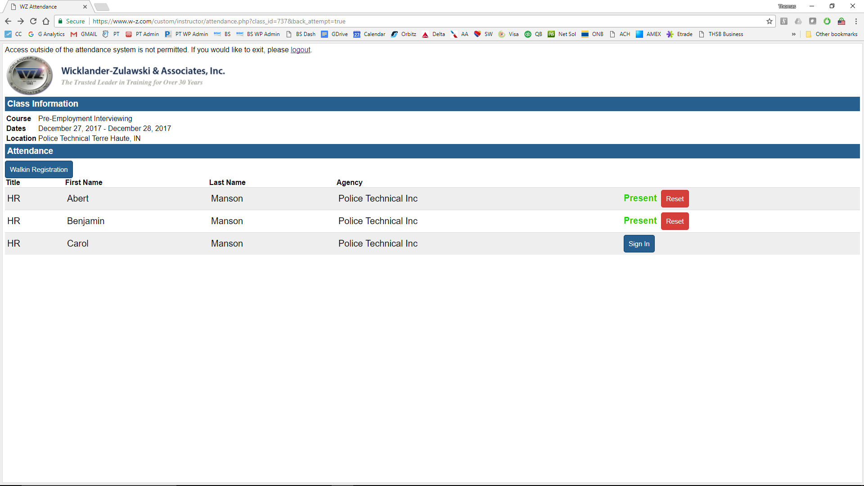
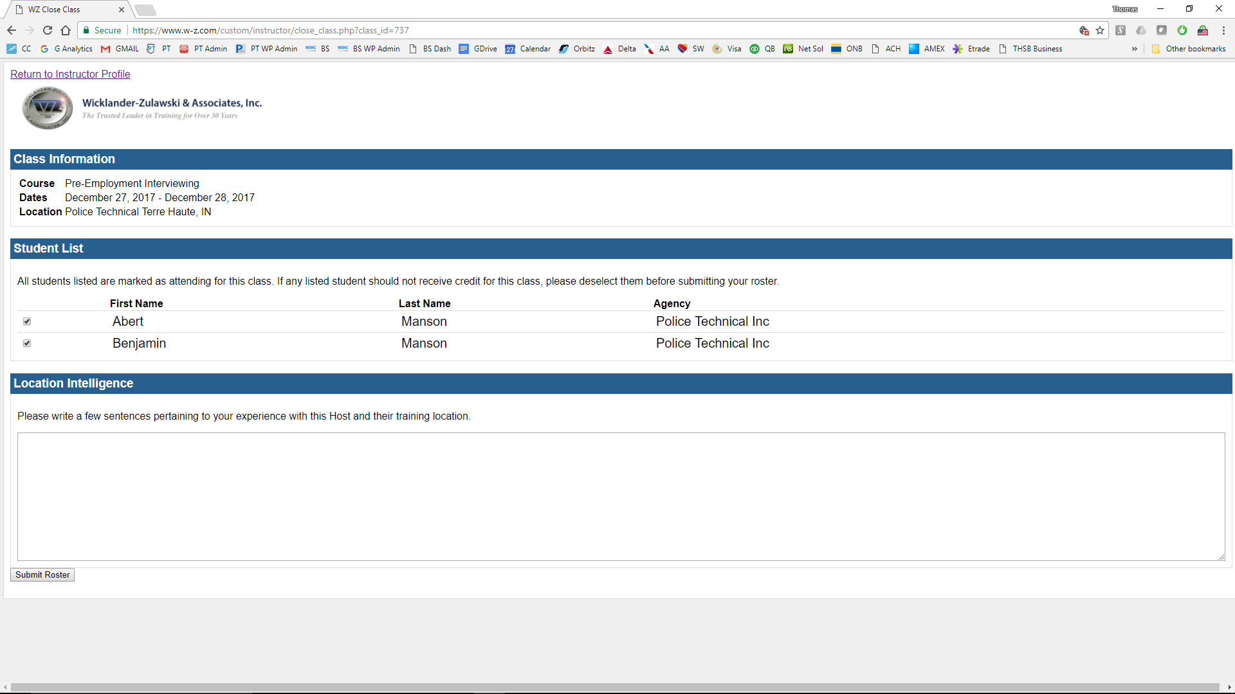

Location Intelligence
The Location Intelligence field below the Student List is for students to share information with fellow instructors related to the class location. This information will then be accessible by other WZ instructors when they visit this location from their Travel Views from Courses.
This information is provided to future instructors and is associated with the original instructor’s name and dated. This information (and the insights it provides) can be especially helpful to instructors coming to a new location, traveling to an infrequent location, or visiting a location which has changing or dynamic features or personnel.

After Action Review
From the instructor Profile, each Past Class has an After Action Review (AAR) button. This button allows instructors to complete their portion of the training process by (1) uploading receipts for reimbursement and (2) completing the AAR documentation.
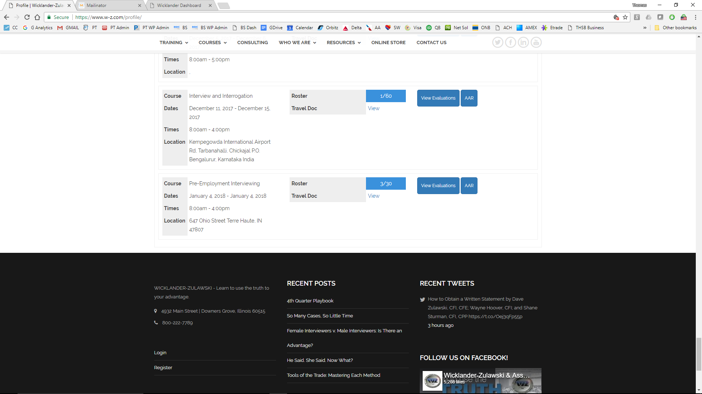
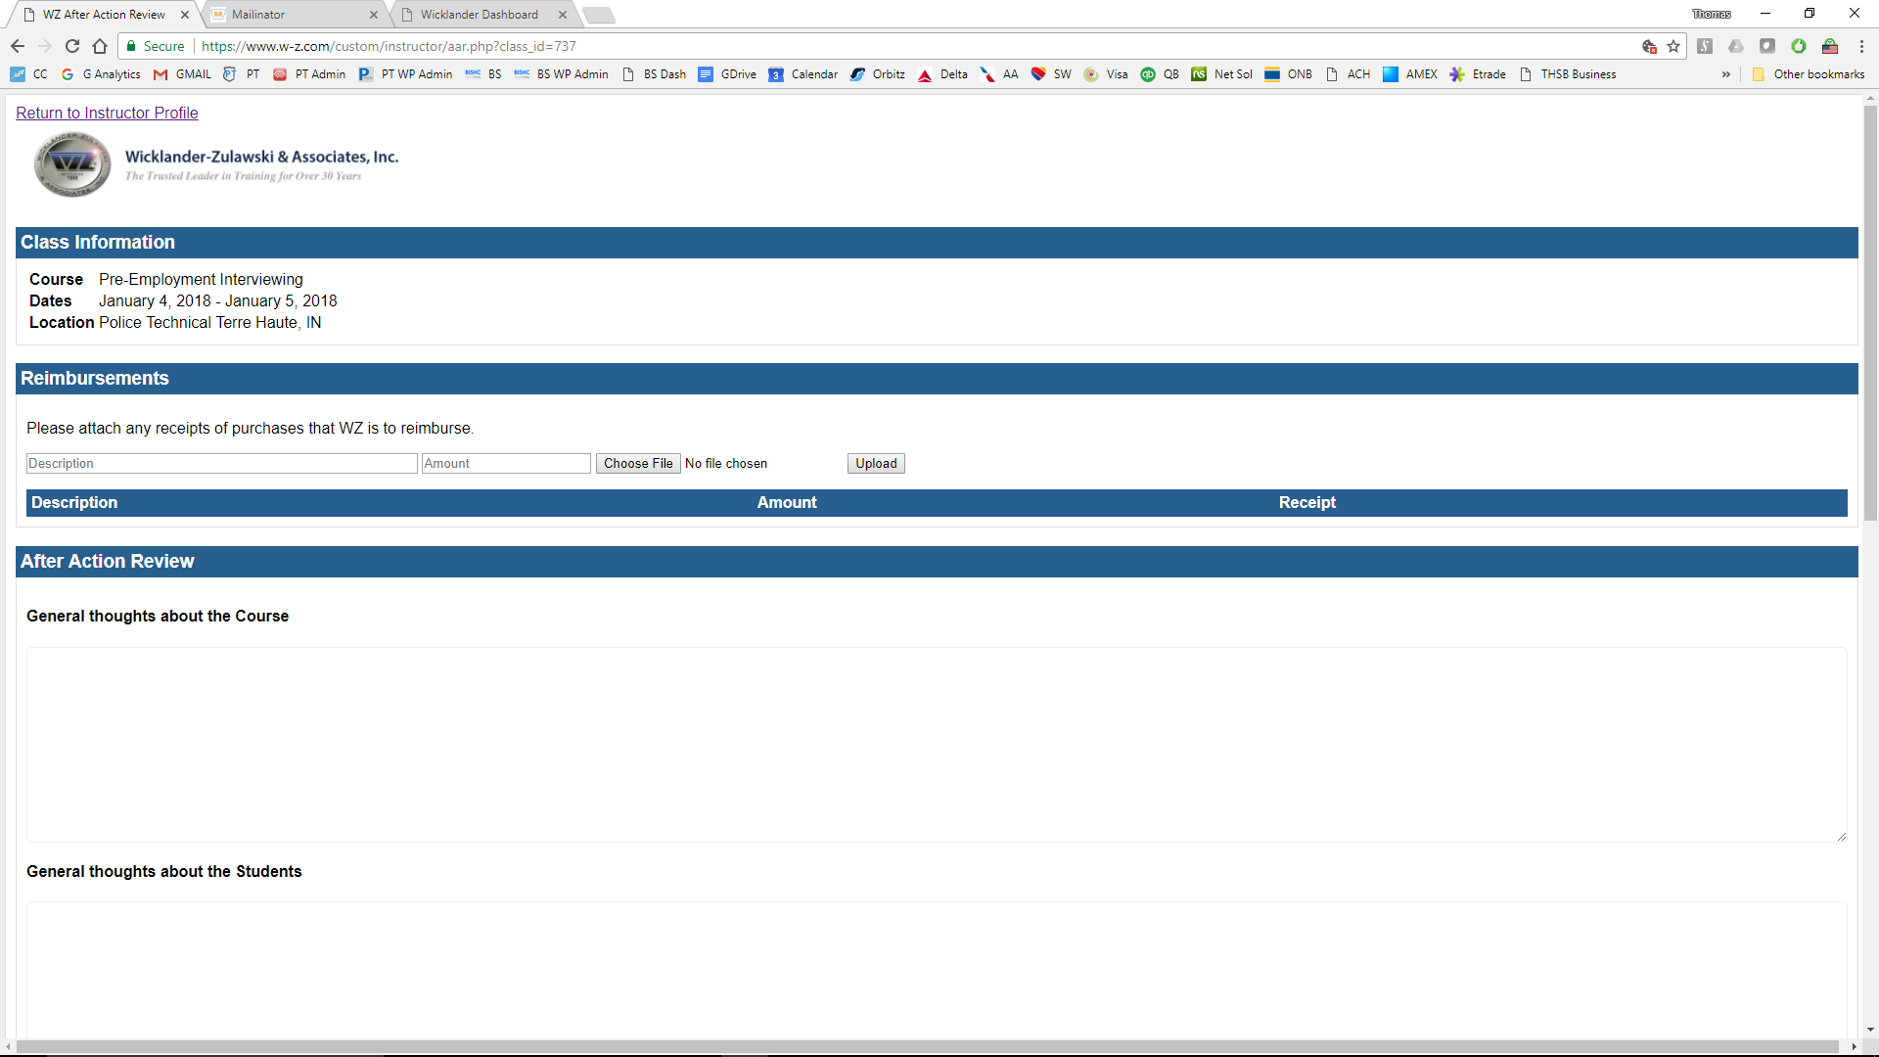

2

1

Reimbursements
This section allows instructors to upload receipts for reimbursement. A description, and amount and a file upload (for the physical receipt is provided.
Once a file is selected, described, and an amount added, it can be uploaded via the “Upload” button.

AAR Questions
The AAR consists of the following 6 questions, with space for several lines of narrative. Each question, and its answer, is designed to provide feedback to WZ about the recent course, it’s specifics, and give the instructor an opportunity to communicate important information back to WZ.

- General thoughts about the Course

- General thoughts about the Students

- General thoughts about the Host Agency and Facility

- Were there any problems/issues during the class? If so, how were they resolved?

- What time did the class begin and end on each day?

- Any leads or follow ups to contact for additional services?

Logging Out of Class Sign In
Logging out of the Class sign in will require the instructor to log out of the entire system to gain access to their own account. This safety protocol is established to prevent a student from gaining access to the Instructor’s Profile, and WZ’s Administrative Backend.
Students or Instructors attempting to return to the Instructor Profile will be prompted to logout of the system.
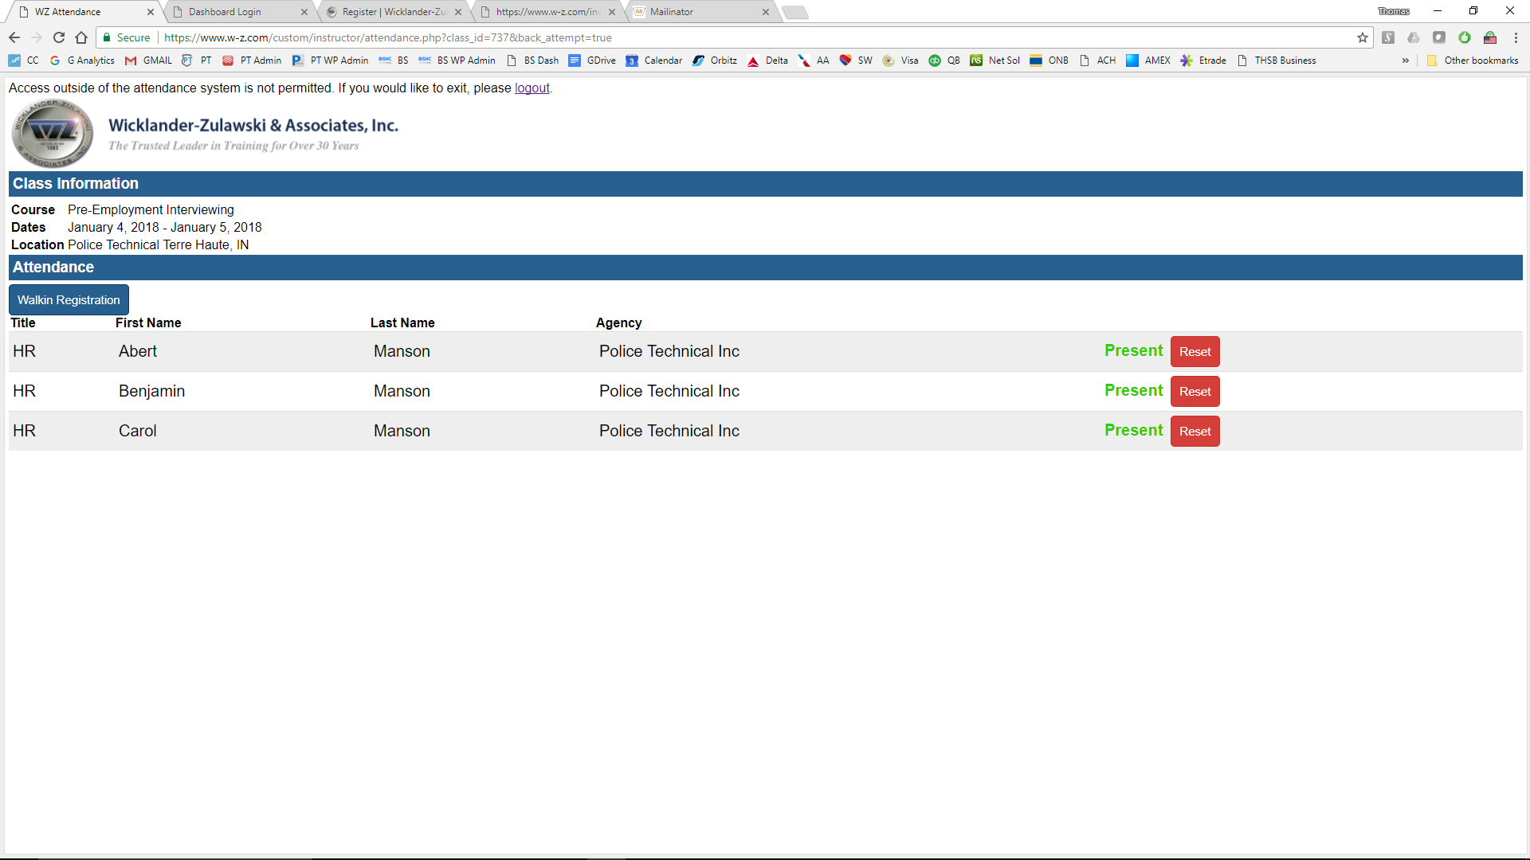
Students or Instructors attempting logout of the system will be promoted twice for confirmation, and will then be required to log back in to the system to gain access to the Instructor Profile.
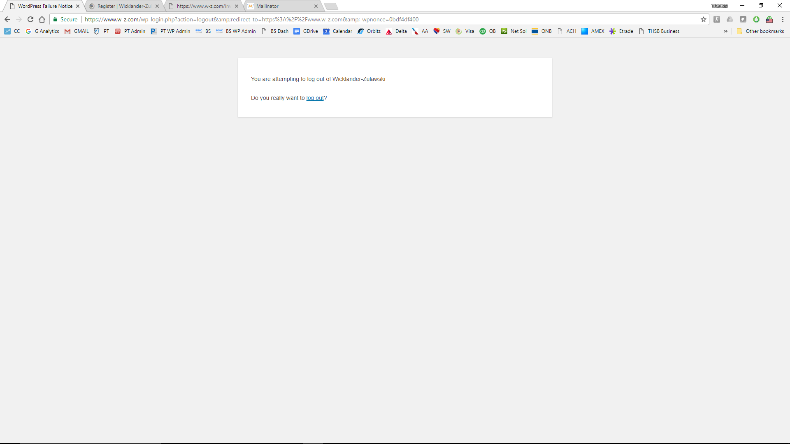

Past Classes Tab
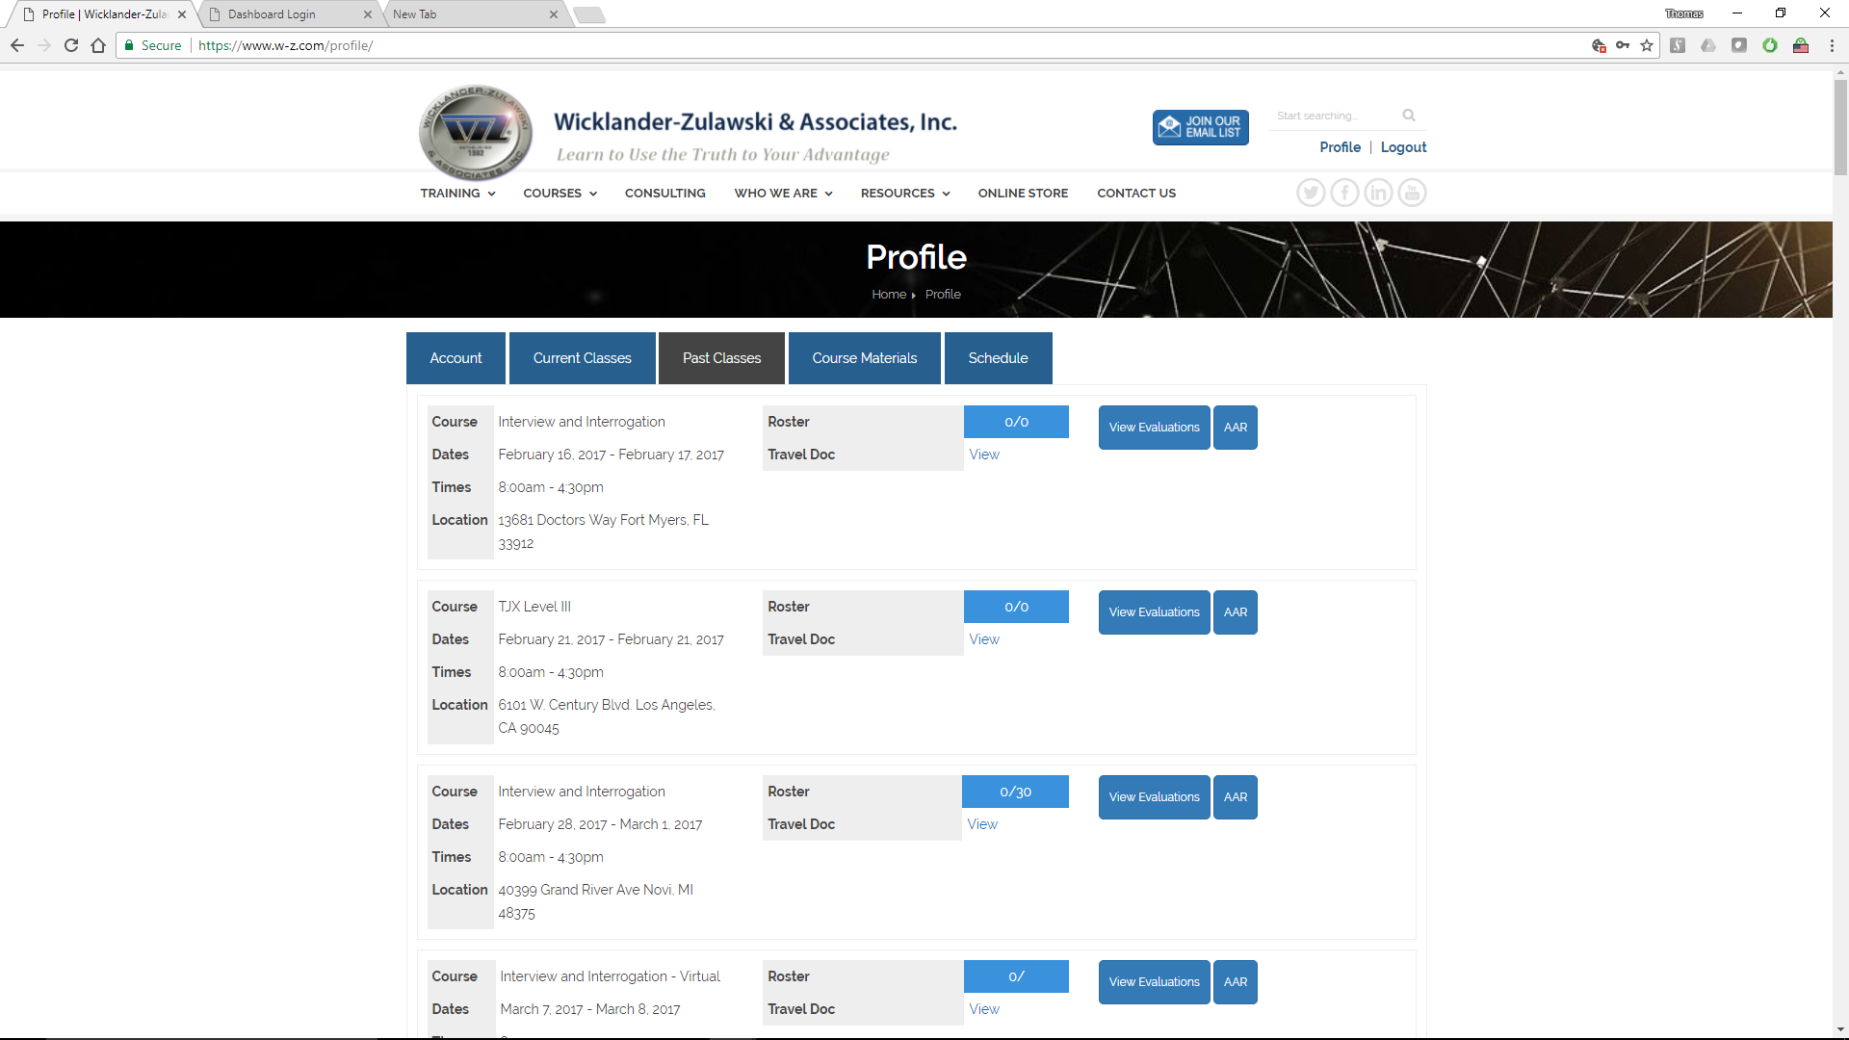
Past Classes Tab shows show all of the instructor’s previously taught courses.
Visible from this interface are:
- Courses taught by the Instructor in reverse Chronological Order (most recent at the top)
  - General Course Information (Title, Dates and Times, location)
  - Roster (of Students)
  - Travel Documentation
  - Evaluations (by Students)
  - After Action Review (AAR)

Viewing Evaluations
After a class is closed, students receive an email encouraging them to complete an evaluation on the class. This serves multiple purposes, it engages the student to immediately engage again with WZ and it allows for course feedback to be accessible by several interested entities at a single time. Evaluations are accessible from the Instructor Profile, the Administrative Backend, and the from the Public Side.
Selecting View Evaluations from any course will take the instructor to the Public side (Web site), to the evaluations from that specific course.
Each evaluation pages provides:
- Course information (Course Title, Instructor, Location, and Training Dates)
- Aggregate scores for a variety of factors are presented on a 0 to 5 scale.
- Percentages for follow Up Questions are presented
- Individual Reponses and Comments (the Comment field is required to have at least one character, it may appear empty, as a single *space* key stroke will meet the requirement).

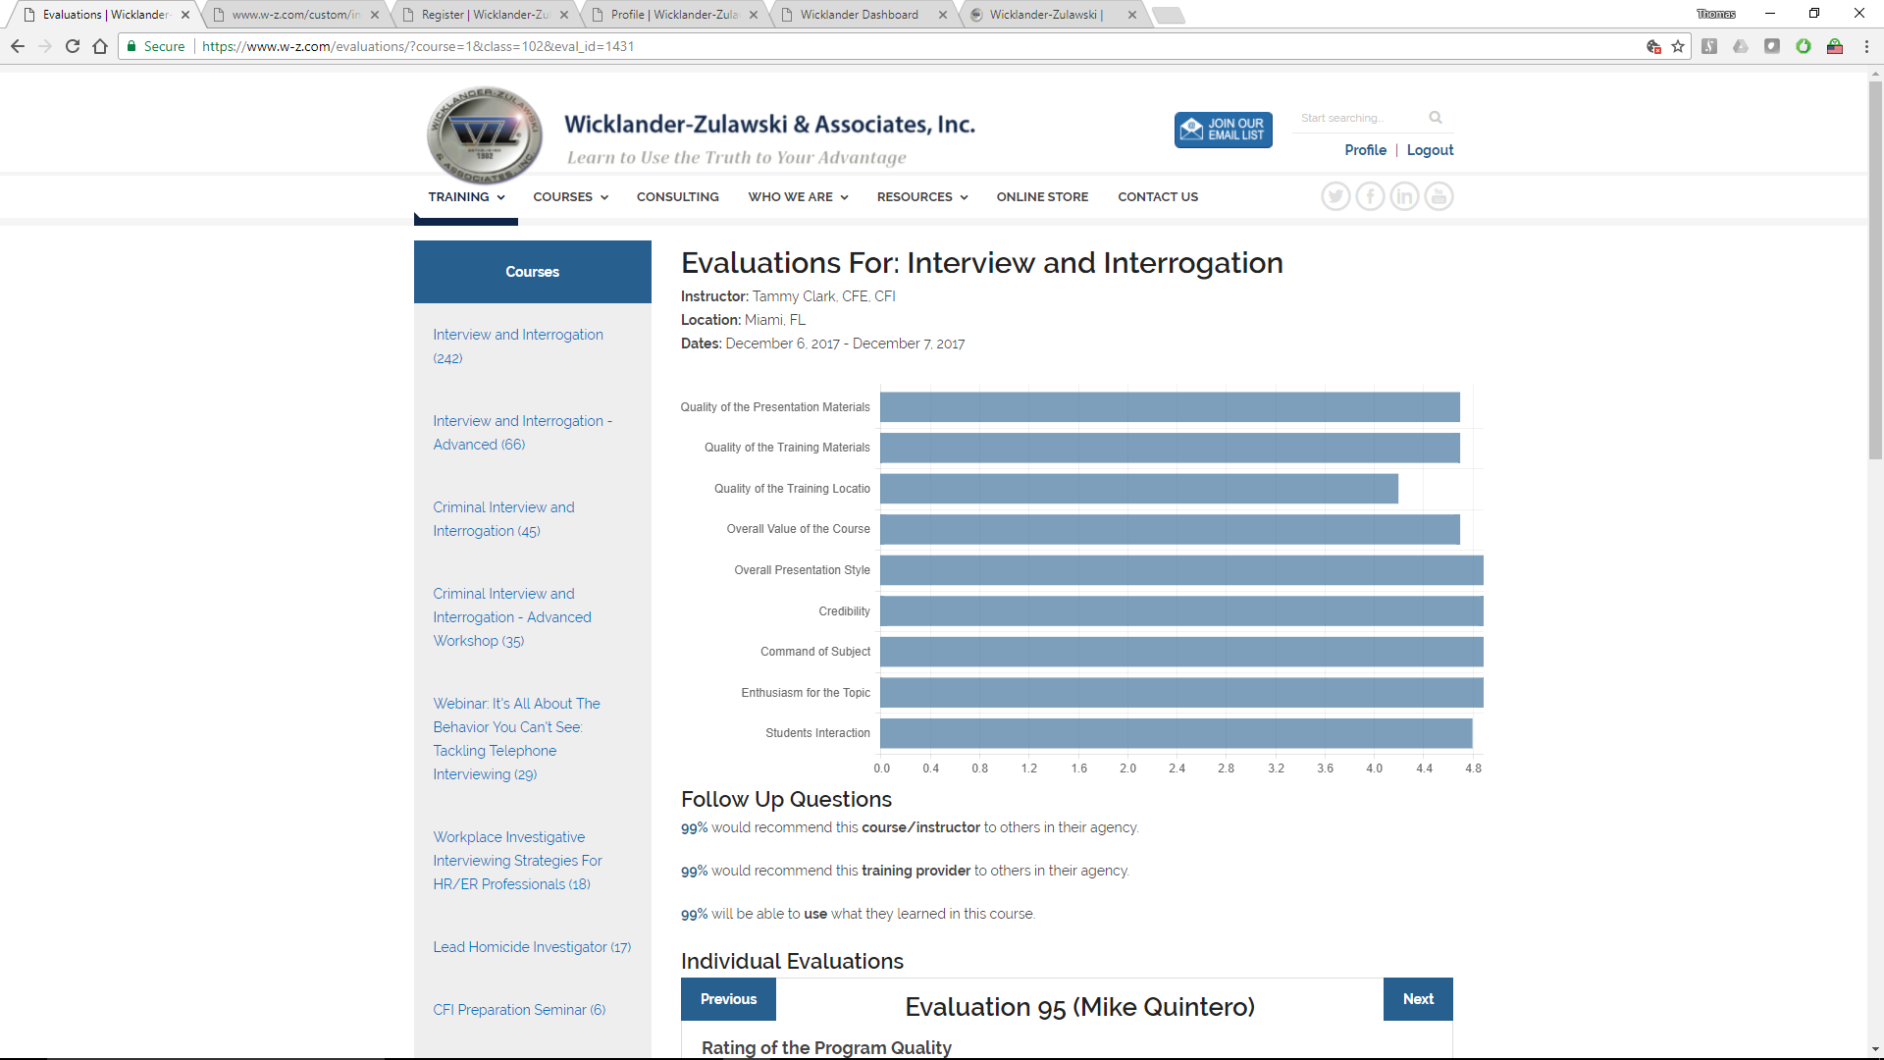

Public Side Evaluations
Few companies publicly share performance evaluations, and very few companies share them all. All WZ course evaluations since the launch of the new website are publicly accessible from https://www.w-z.com/evaluations/
From this page, specific courses can be selected and reviewed. 5 recent, random comments from classes are also presented with hotlinks to their individual evaluations.
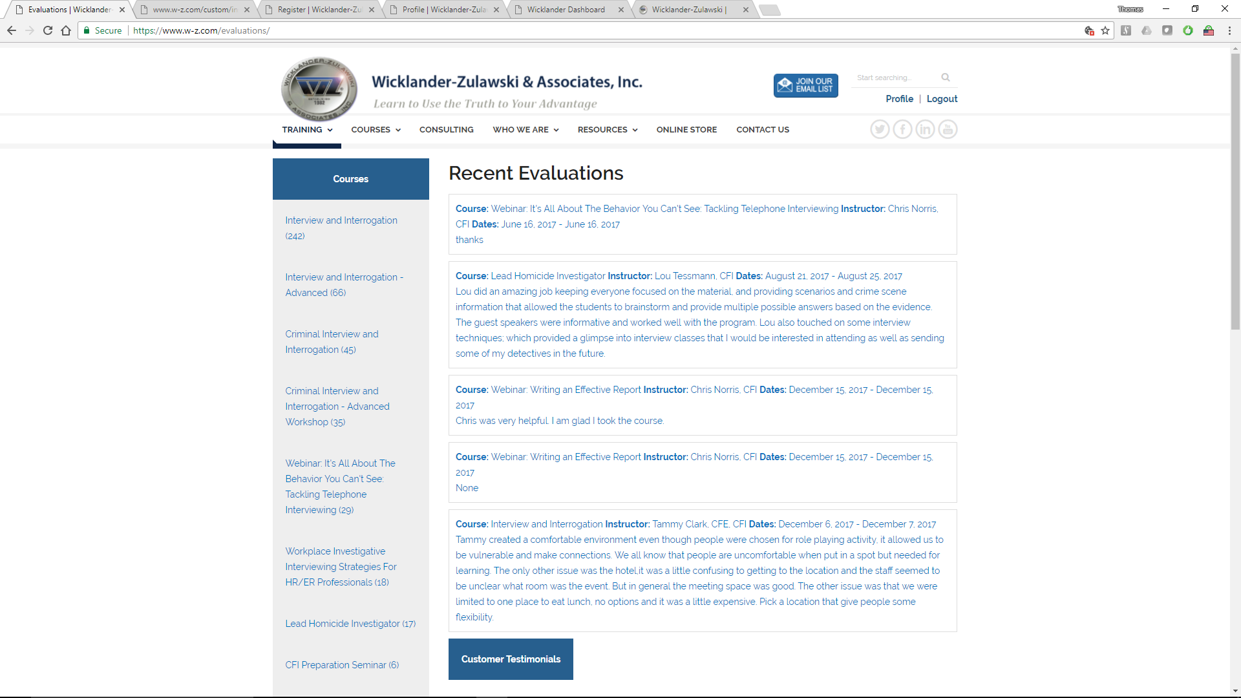
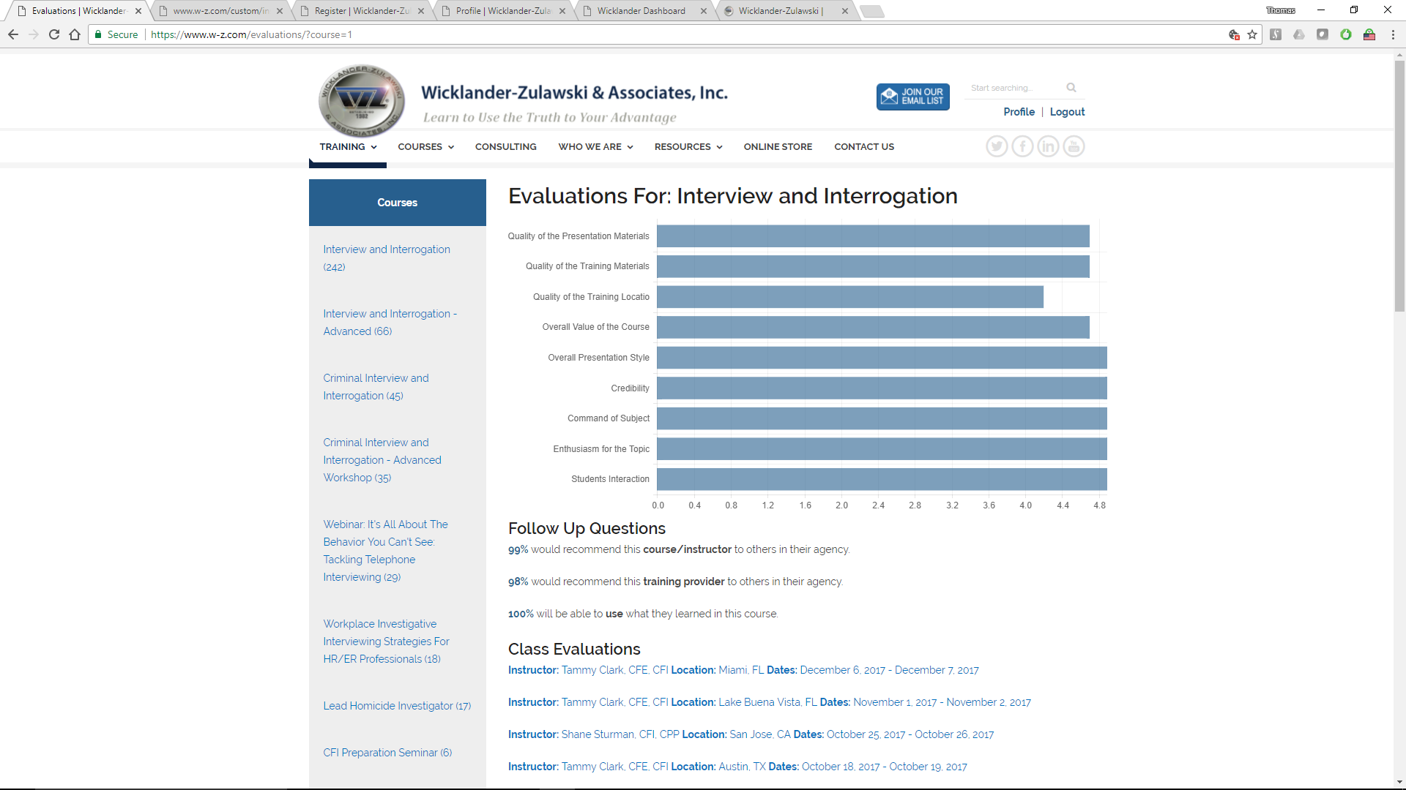

1
Selecting a specific course will provide an aggregate of ALL instances of that course, as well as evaluations for each specific course that has run since the new WZ web site was launched in 2017. Clicking on a specific instance (1) will open the evaluations for that course, showing aggregate values specific to that course and individual evaluations. Each evaluation is accessible via Previous and Next buttons in the corners (2) .

2
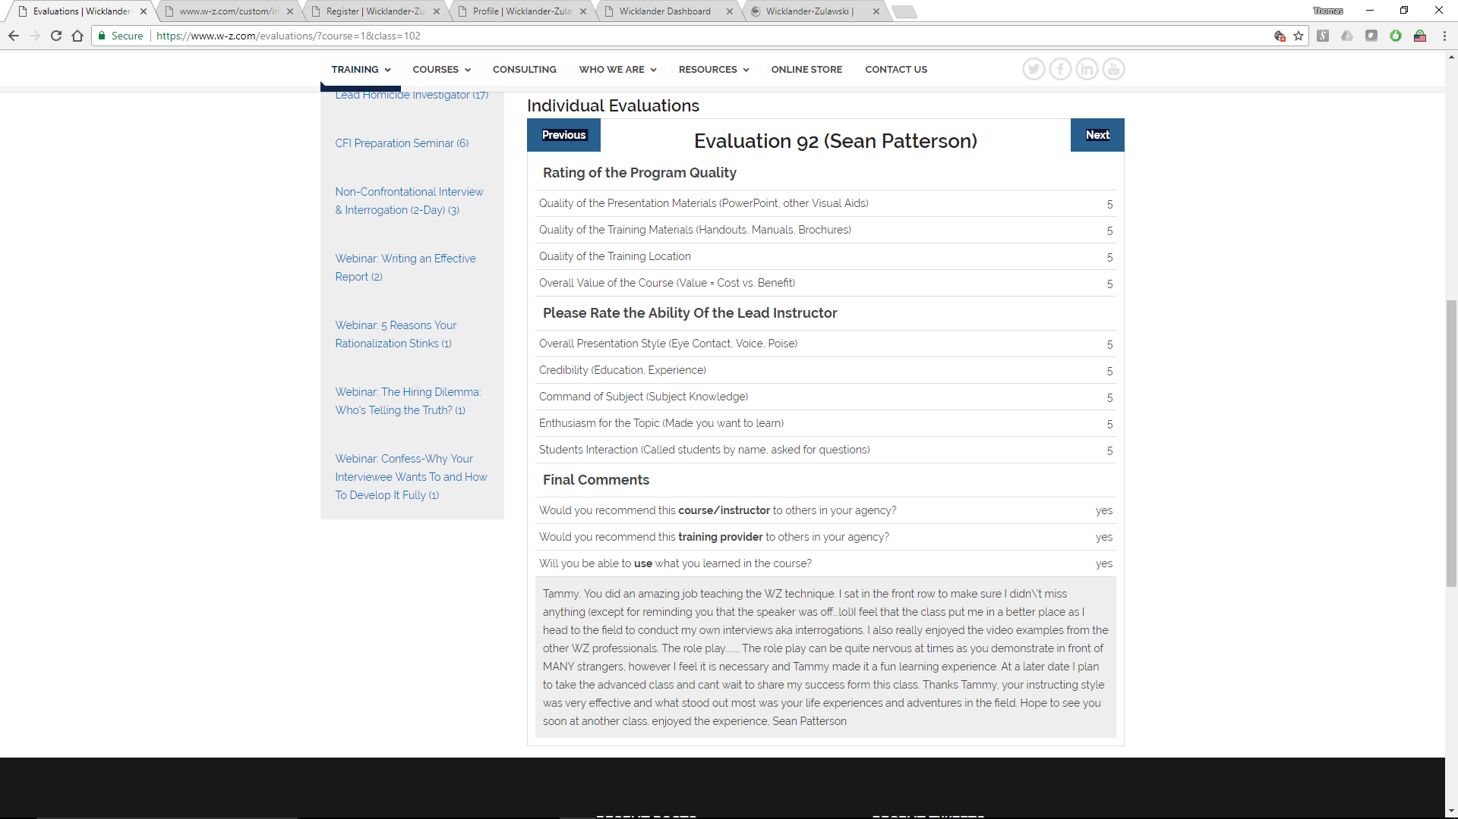

Course Materials Tab
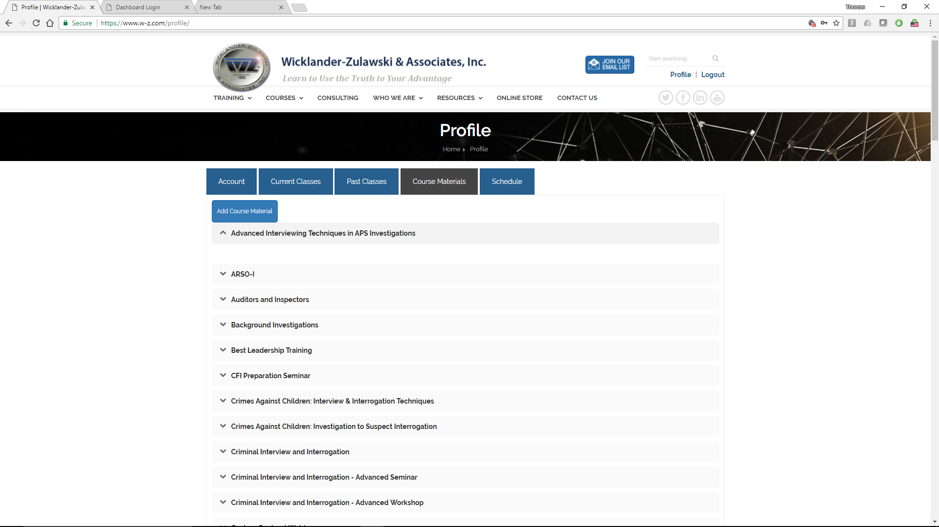
The Course Materials Tab provides a location for instructors to upload digital materials for students enrolled in the specific subjects.

Example 1 – Pre-Class Materials
As background material for an upcoming section of Background Investigations an instructor wants their Students to have (be able to download) a recent article on Background Investigations BEFORE the class. That article could be uploaded to via this interface to the Course Materials. Once it is uploaded, registered students in the course Background Investigations will have access to the document. The document can be deleted later, or allowed to remain for future students.

Example 2 – Post-Class Materials
An instructor teaching Background Investigations wants their Students to have (be able to download) a recent article on Background Investigations they had written. That article could be uploaded to via this interface to the Course Materials. Once it is uploaded, students will have the ability to download the document for themselves.
Instructors have used this section effectively by uploading materials, and then encouraging their students to access them to further their research or inquiry into a subject. Often times there is not enough class time to share everything an instructor wishes. This section provides a single access point for sharing information across an entire group of students.

Notes about Course Materials
- Course Materials is a great way to share course specific materials to a specific audience
Students are often very interested in a specific subject, and are often looking for MORE at the end of training. Course Materials can often meet some of that future demand, as well as reassuring highly engaged students that “there is more” (at this location). Course Materials also provides encourages students to re-engage Wicklander- Zulawski & Associates after the class is over. This continual dialog is critical to a student’s educational success; and the continued success of WZ.

- Course materials are course specific, not specific to a single instance of a course.
For example, materials uploaded to the Background Investigations section will be accessible to ALL current and former students registered in ALL sections of any instance of Background Investigations. They will ALL be able to view and download the material, and keep them.

- Course materials can be uploaded and deleted by Instructors
For example, Instructor A primarily teaches Background Investigations. She can upload materials into the Background Investigations section, AND ANY other course she chooses. She also has access to delete any material from the Background Investigation section AND ANY other course she chooses.

- WARNING - Course Materials is not to be used for Proprietary WZ Training Materials
For example, Instructor A primarily teaches Background Investigations and wants to share her presentations and instructional guides with another instructor who will soon be teaching the same course. If Instructor A uploads these materials into the Background Investigations section, ANY student enrolled in this course will have access to the materials.

Guiding Questions to ask PRIOR to uploading documents to Course Materials
- Would this document be helpful to students in this course?
- Is it acceptable that WZ students (past / present / future) access this document?
- Does this document continue the learning objectives of this course?
- Are there any ethical or legal questions about the upload / or download by others of this document?

Adding Course Materials
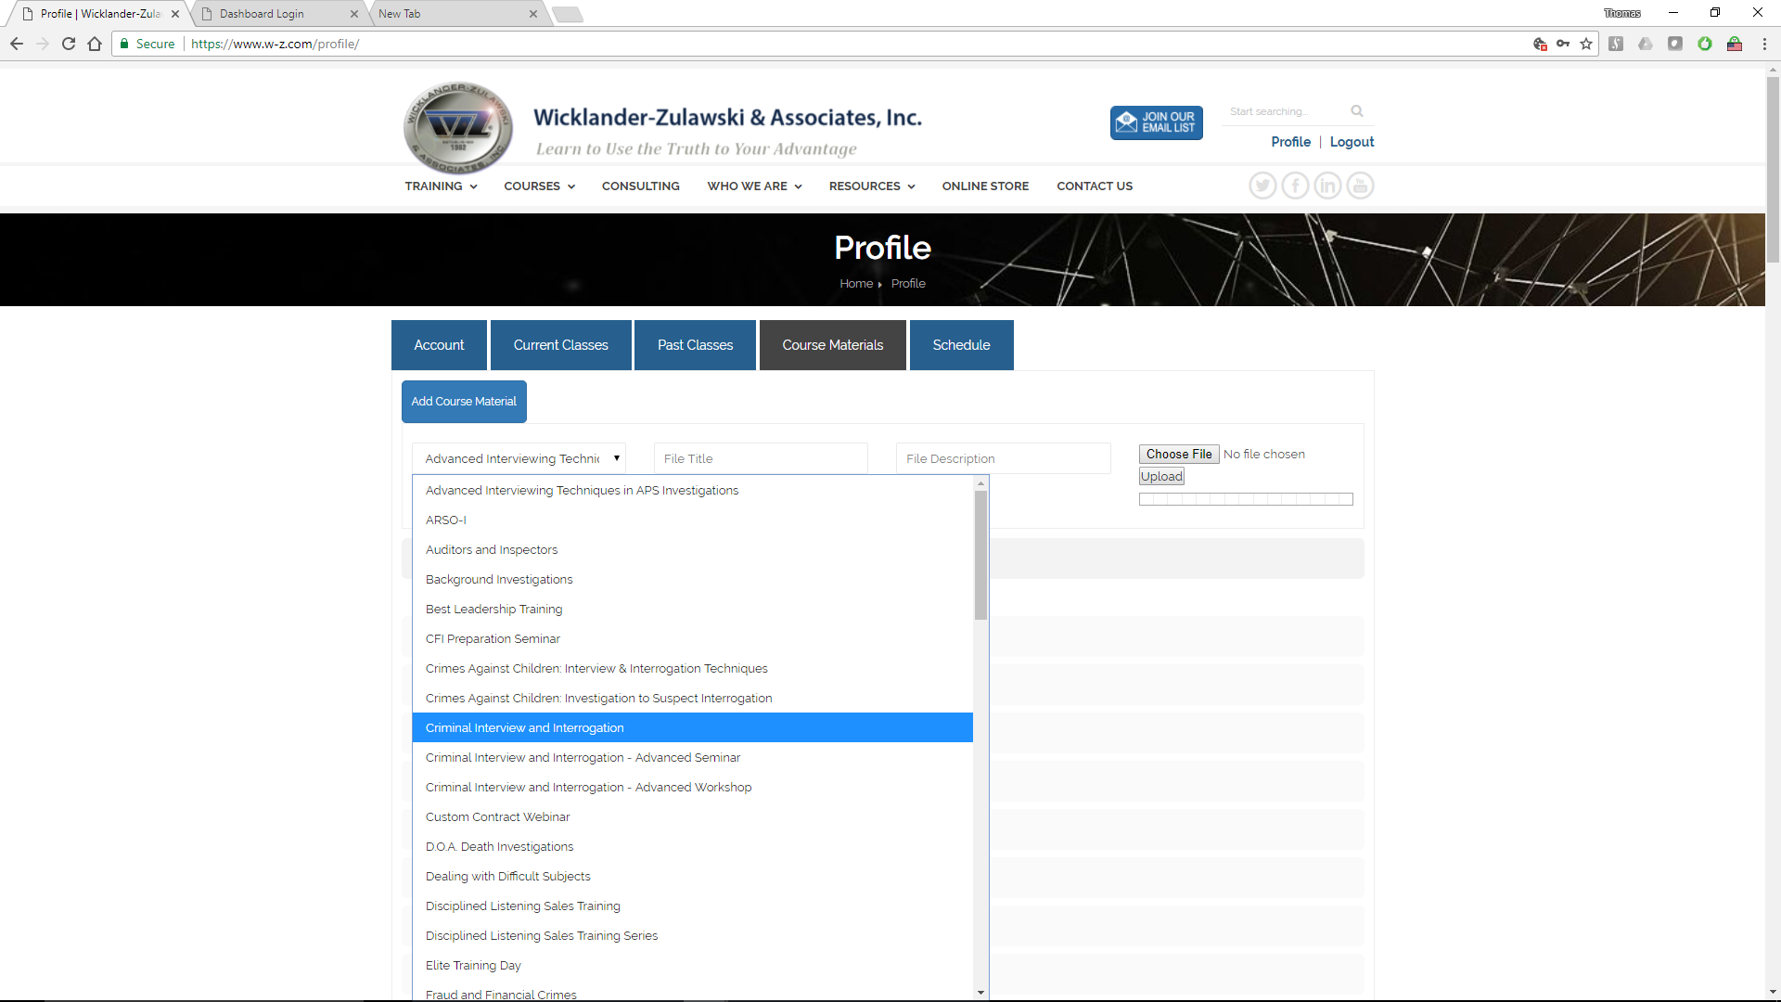

3

2

1
Course materials can be added to any course by
- Selecting the appropriate Course from the drop-down menu.
- Choosing a File Title and adding File Description
- Choosing a File and the selecting the Upload button
The file will then be uploaded and immediately accessible by students.

Deleting Course Materials
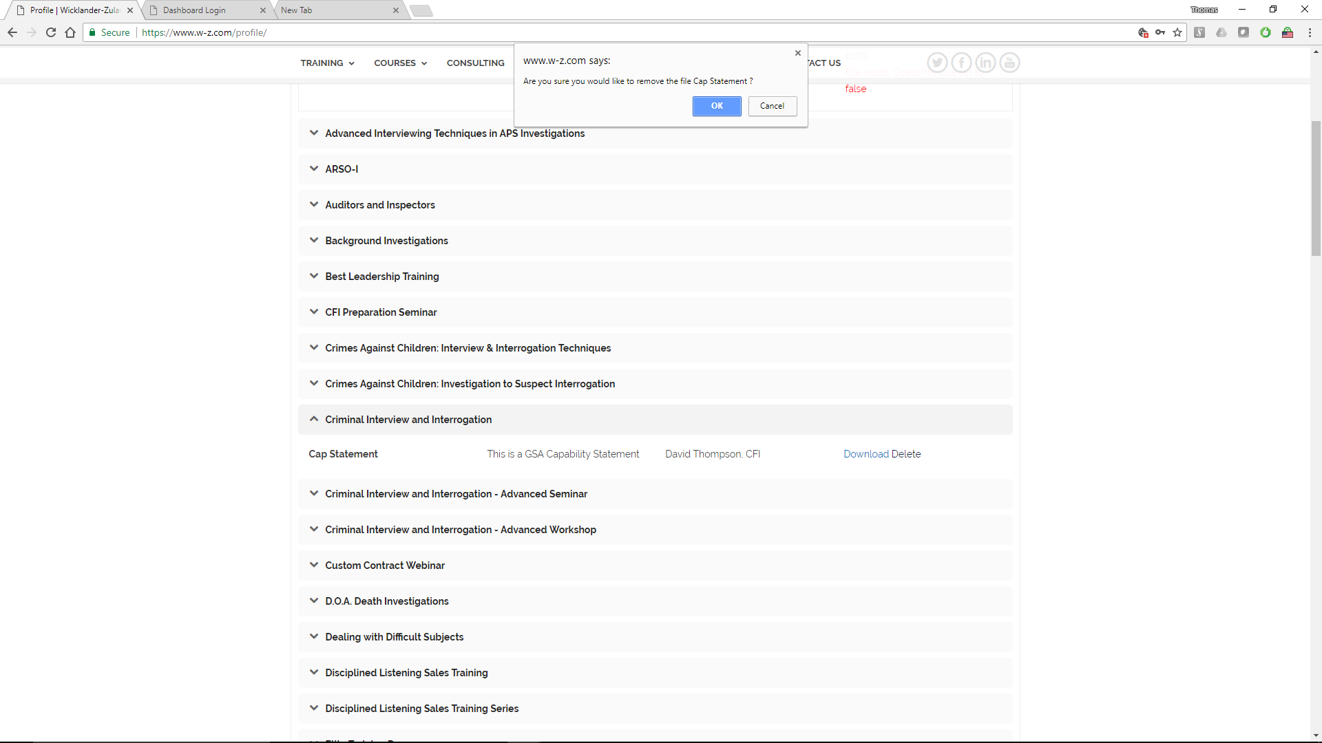

2

1
Course materials can be added to any course by
- Selecting the appropriate File from a specific Course, and selecting Delete.
- Selecting OK from the pop-up menu.
The file will be immediately deleted from Course Materials and no longer accessible to students or Instructors.

Schedule
The Schedule tab on the Instructor’s Profile allows an instructor to select a range of dates they are available to work. It is understood that the day before a selected range would likely be a travel day
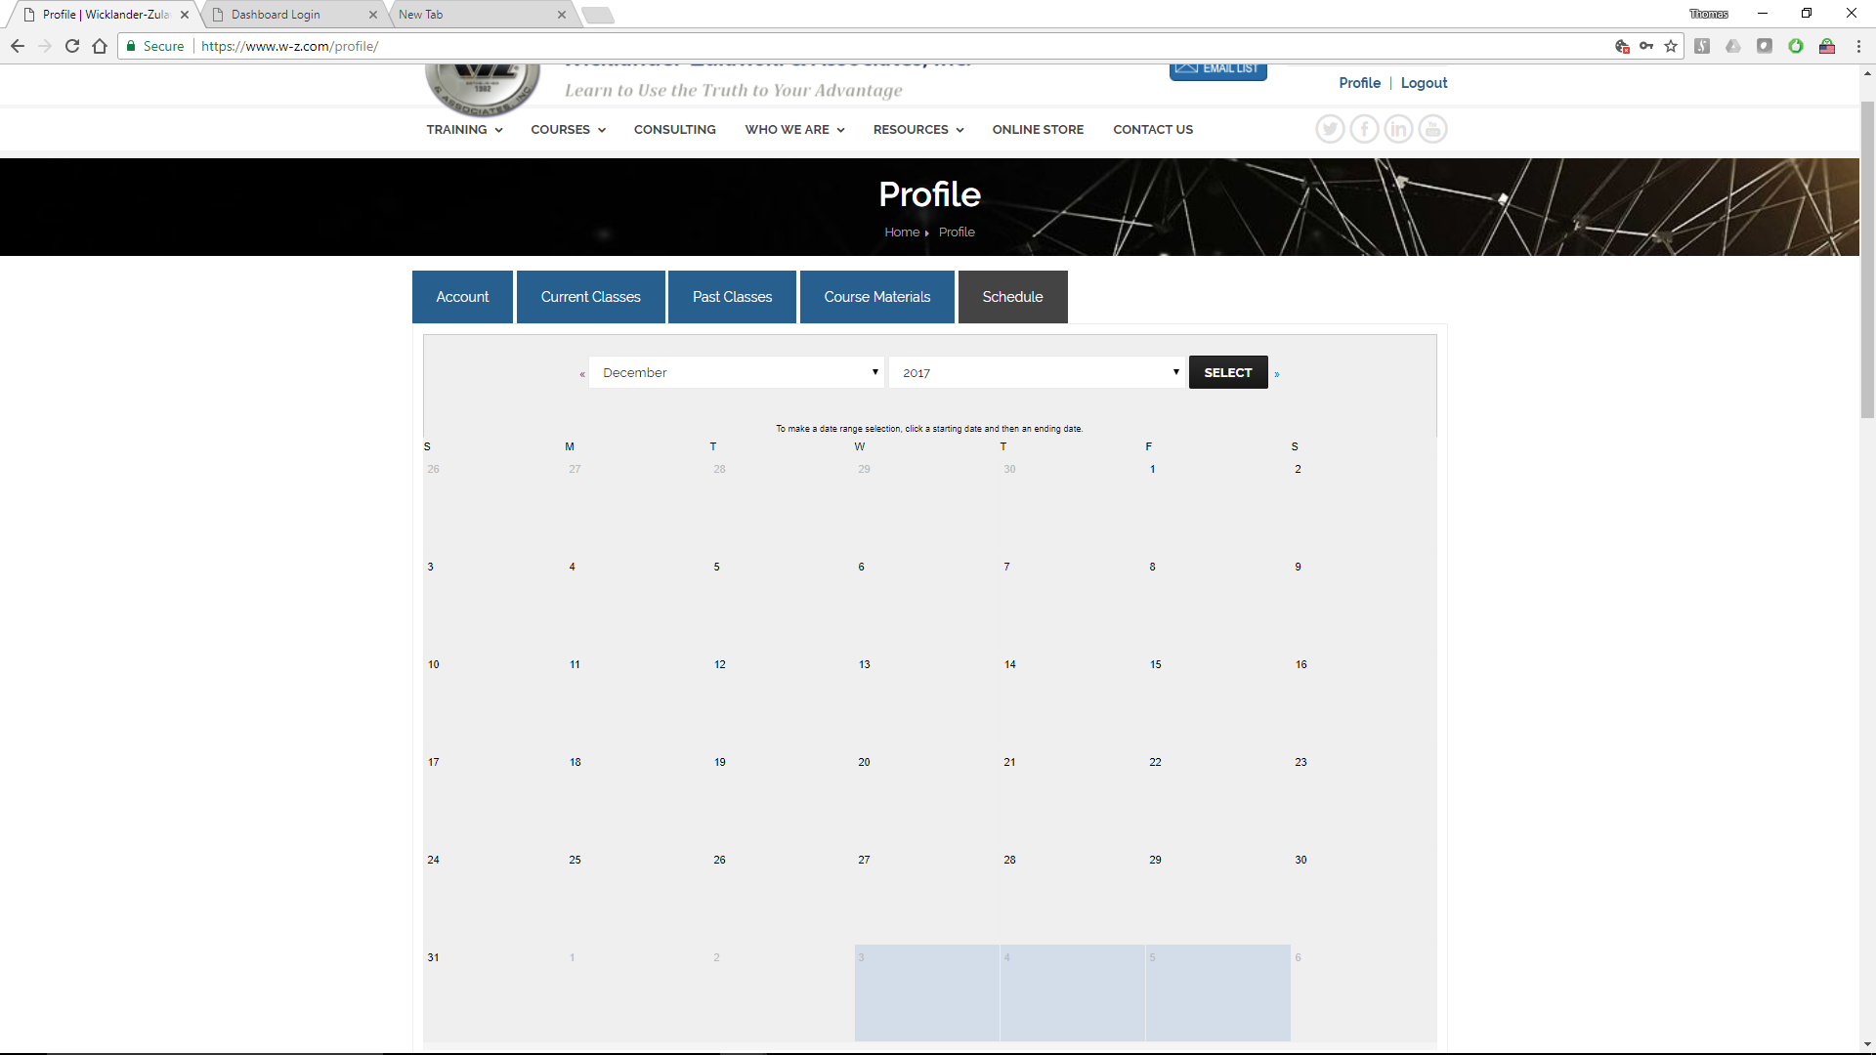

In the example below, January 1-2 have been selected, by first clicking on Jan 1, then clicking on Jan 2. They are highlighted and the instructor has the option to select either LOCAL of GLOBAL from the drop down list on the left.
The instructor can then select MARK AS AVAILABLE or CLEAR (to clear the selection).
Dates can be SELECTED or DE-SELECTED by clicking on them
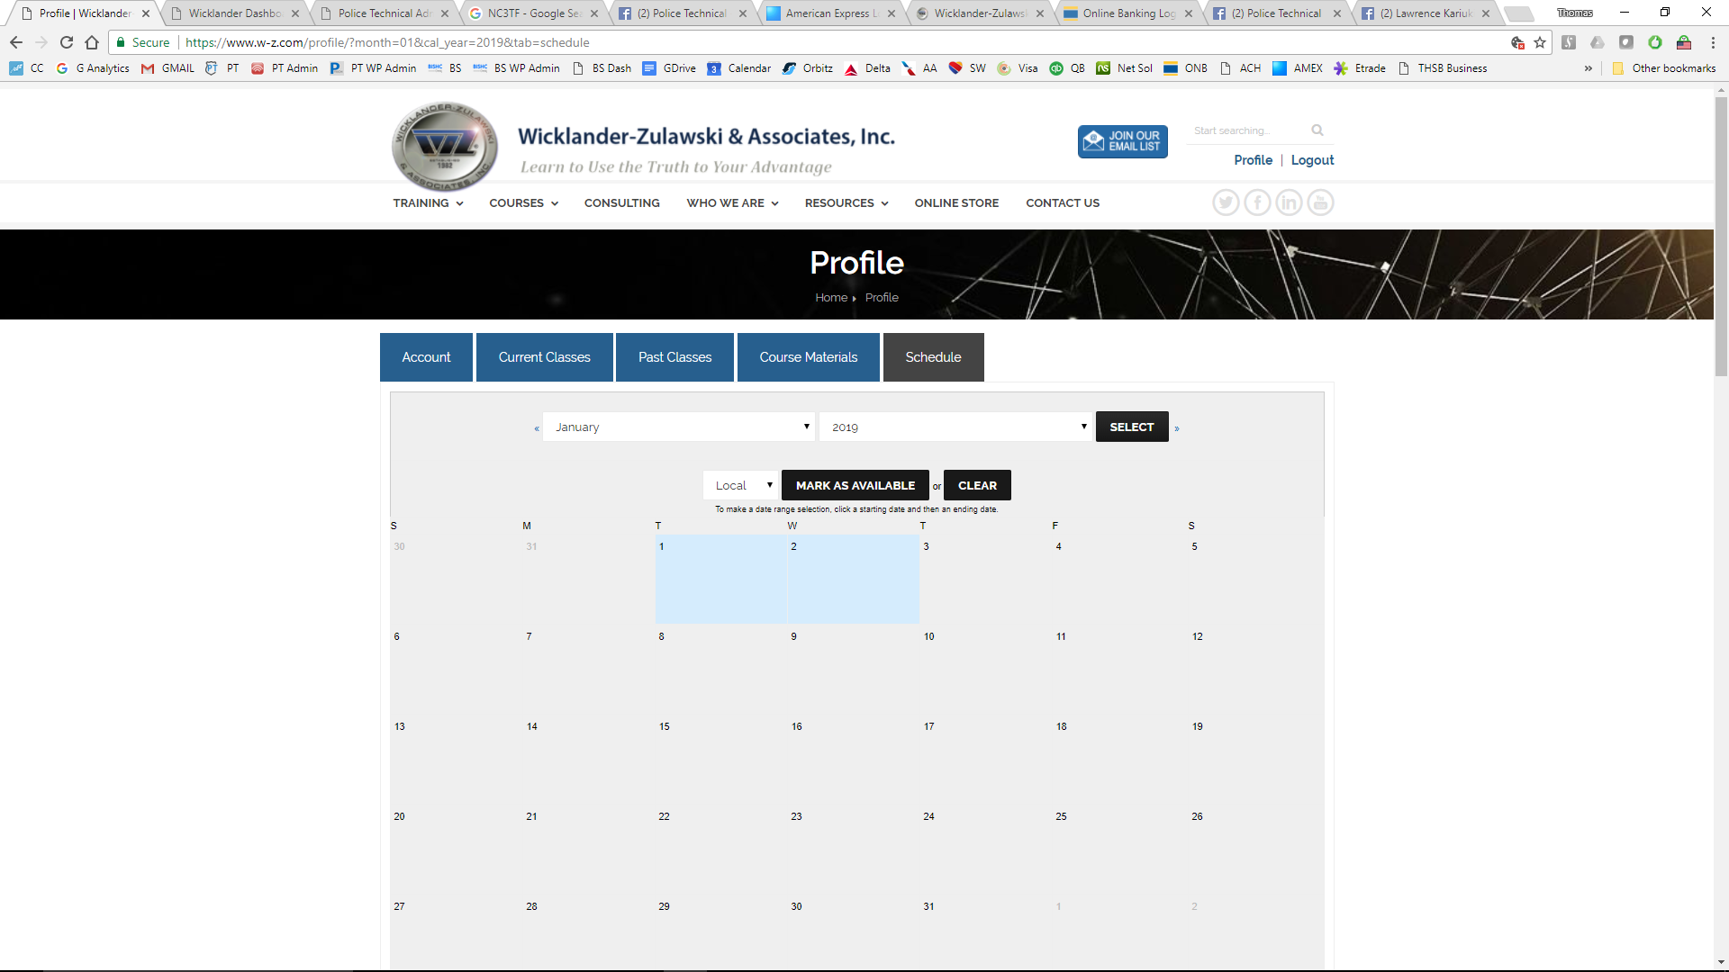
Dates which are selected will appear on the list at the bottom of the pages. These are the dates the instructor has indicated they are available to work, or the dates which they can be scheduled.
