PowerPoint® for Public Safety™

From Basic Design to Video Capture
Applications and Strategies for
Public Safety Personnel

PowerPoint® for Public Safety™ was specifically designed for personnel tasked with making and presenting information about the operations and processes of public safety. Within this manual are the best practices which will allow personnel to more efficiently create more effective presentations.

Thomas M. Manson
Police Technical
www.policetechnical.com

Table of Contents
Welcome! 4
Our History 4
Goals of the Course 5
Course Overview 5
Three Big P’s 5
Three Big Q’s 5
Starting PowerPoint® 6
The First Slides 6
Button, Ribbon and Tabs 7
Faster Development 10
Copy and Paste and Promote 10
Microsoft Word® and XML 12
Table of Contents 16
Cover Page 17
Using PowerPoint® 18
Insert 18
Table 18
Picture 19
Clip Art 20
Photo Album 21
Shapes 23
SmartArt 27
Chart 28
Design Themes 29
Saving and Publish 30
Presentations 30
Shows 31
Other Options 32
Publish 34
Handouts in Microsoft Word® 36
Security 36
Printing Presentations 38
Hyperlinking 39
Rules of Hyperlinking 39
Action Buttons 39
Action Settings 40
Hyperlinks 45
Creating a Splash Screen® 46
Creating a Timeline 47
Games 48
Promotional Package 49

Animation 50
Transitions 50
Animation through Transition 50
Stacking Order 51
Selection and Visibility Tab 52
Custom Animation 53
Entrance 53
Emphasis 54
Exit 55
Motion Paths 56
Effects and Timing 57
Advanced Timeline 58
Animating Text 59
Diagramming Process 60
Animation Case Study – Vehicle 61
Audio 62
Adding a Soundtrack 62
Record Narration 64
911 Recording and Text 65
Video 66
From the Internet 67
Camtasia 68
Other Options 70
Keyboard Shortcuts 71
Autocorrect 72
Master Slides 73
Templates 74
Presenters View 76
Review 77
Research 77
Translation 78
Comments 79
PowerPoint® Options 80
Police Technical National Courses 82

Welcome!
Good morning and thank you for attending this Police Technical course.
My name is Thomas M. Manson, founder of Police Technical, the company which is presenting this technical training course. Today you will be an attendee in a course which police technical and your instructor have been preparing for many months, and, truthfully, have been preparing for many years.
Police Technical has worked for several months to make your class today a reality. Each year we receive training requests from agencies across the country, and every successful class is the culmination of 4-6 months of coordination, marketing, and logistics. A May or June class likely began with a training request from the previous year.
Your instructor has also worked for many years preparing to teach this class. In addition to several years of law enforcement experience, many dedicated to the subject of your class; he or she has completed a lengthy process with
Police Technical to become one of our instructors. This process involves a documented hiring process, a thorough background investigation, a detailed instructor and materials development process, and a continuing program of mentorship.
Police Technical and our instructors work hard to provide superior quality training for law enforcement in computer applications, online investigations, and forensics. I can tell you without hesitation, “Your course today will be one of the best you have ever had in this subject, and your instructor is one of the best in the field of law enforcement”.
I know you’ll find this class valuable, but if ever want to talk with me about your experience, or if you would like to talk about bringing a Police Technical training course to your agency or department I would happily speak with you.
Enjoy your class, and thank you again for attending this Police Technical course.
Respectfully,
Thomas M. Manson
Police Technical
812-232-4200 | www.policetechnical.com | info@policetechnical.com

Our History
In 2004 Police Technical LLC was establish to further professionalize the law enforcement training process created by Thomas M. Manson.
In 2007 Police Technical was recognized as a Sole Source Provider by federal law enforcement agencies, offering a level of training unavailable from any other source. Police Technical incorporated in 2009 to provide a suitable structure to expand business operations.
In 2010, Police Technical scheduled more than 50 national training courses (primarily PowerPoint® for Public Safety™).
In 2012, s new classes were developed and being taught by 6 additional instructors.

Goals of the Course
- To review the concepts which make a successful presentation
- To provide a basic understanding of PowerPoint®
- To provide the knowledge, skills, and materials to master PowerPoint®
- To provide a detailed analysis of custom animation
- To provide the knowledge to capture objects for use in PowerPoint®
- To provide information about saving and presenting presentations
- To facilitate communication among attendees and agencies
- To improve training through better communication and technology

Course Overview

Three Big P’s
- Presentations Skills

- Preparation

- Practice

Three Big Q’s
- Who is my audience?

- What do I want them to Know, Do or Believe?

- What is the most effective way to accomplish my goal?

When is it too much?

Starting PowerPoint®

The First Slides
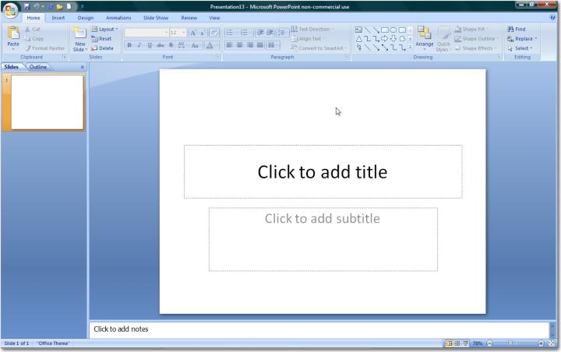

Button, Ribbon and Tabs
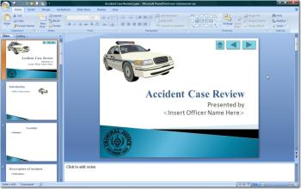 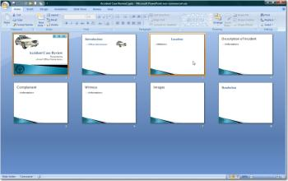
Normal
Slide Sorter
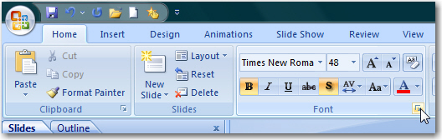
Pressing this icon will expand the options available to the user.
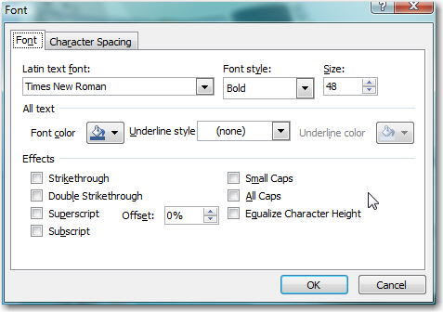
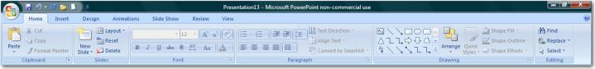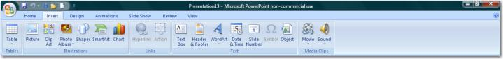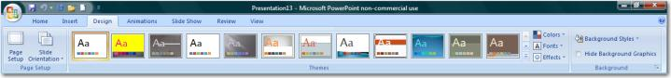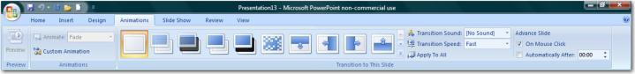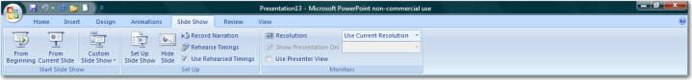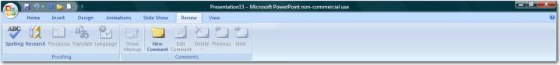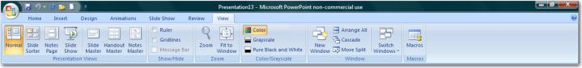
Slide Show Tab
View Tab
Animation Tab
Review Tab
Design Tab
Insert Tab
Home Tab

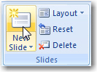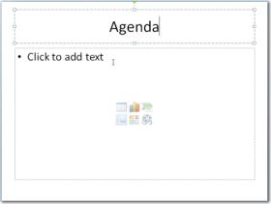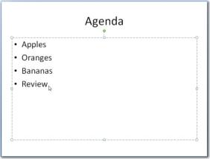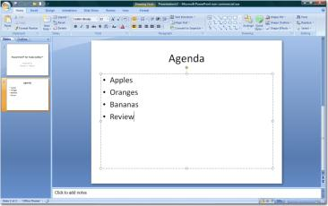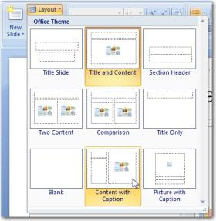
Slide layouts may be changed from the Layout drop down menu.
Typing in the text box will allow the creation of “bulleted lists”, will removing the insert options box below.

These items may be added later from the Insert tab.
“Bulleted List” slides offer six different insert items:
Table
Charts
Smart Art Graphics
Insert Picture
Insert Clip Art
Insert Media
View Tab

Faster Development

Copy and Paste and Promote
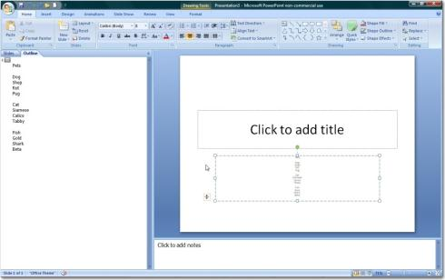
Open PowerPoint and Paste the copied text in the subtitle box.

Faster Development starts in Microsoft WORD with a simple outline.

Copy the outline with CTRL-C or right click and Copy.

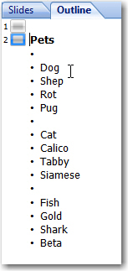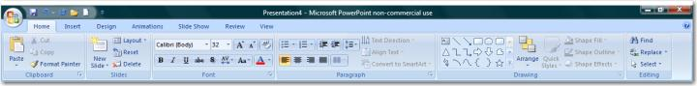
From the outline tab, place your cursor in front of the first word in the outline and promote it using Shift+Tab.

Repeat this process on the remaining main points.

Note: Delete the first blank slide.

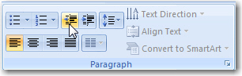
Promote and Demote buttons are also found on the Home tab, in the Paragraph section.

Shift+Tab = Promote

Tab = Demote

Microsoft Word® and XML
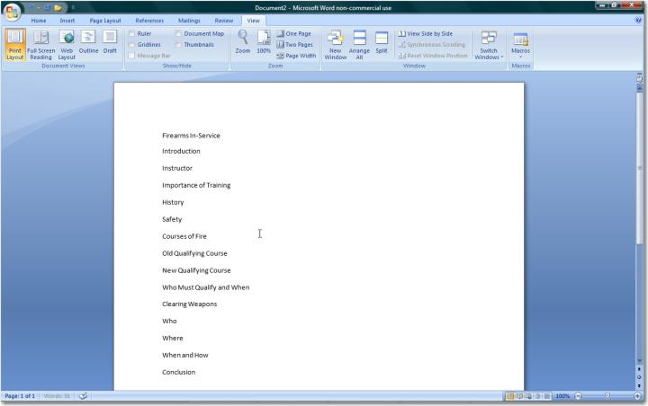
XML is a programming language which allows programs to interact more efficiently.

In WORD® create a simple outline.

Then apply headings from the Home tab, Styles section.

Heading 1 – will turn into Slide titles
Heading 2 – will turn into bullets
Heading 3 – will turn into sub points

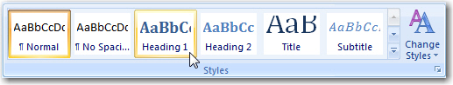
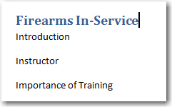
“Firearms In-Service” has been formatted with Heading 1.

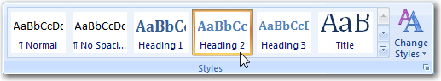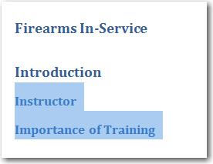
“Instructor and Importance of Training” has been formatted with Heading 2.

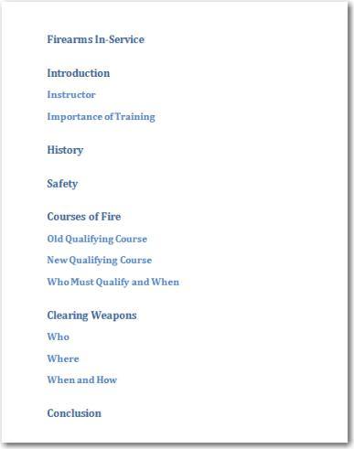
This outline has been completely formatted with Headings.

Save the document as a 2007 WORD® document; with the .docx extension.

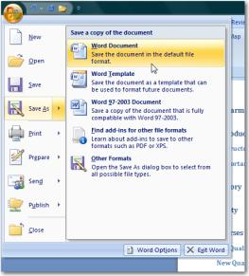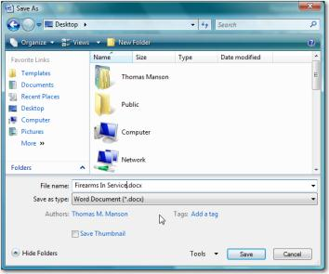
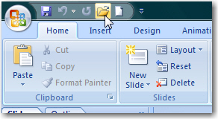
Once the document is saved as a WORD® 2007 or .docx file, close it. Next, open PowerPoint® and open the document using the Open file command.

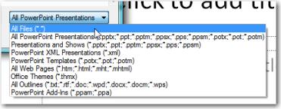
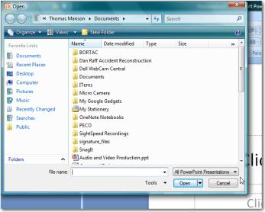
PowerPoint® typically tries to open its own file types exclusively. Make sure “All Files” are selected to be shown.

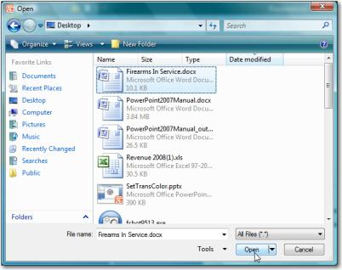
Selected the appropriate WORD® file, and click Open.

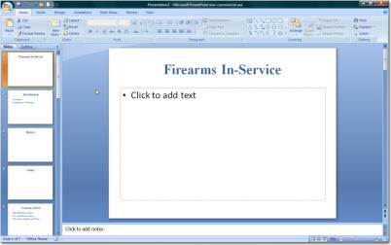
The Headings within the document will show in PowerPoint.

Heading 1 creates a new slide its text as the title.

Heading 2 creates a bullet below the previous Heading 1.

A new Heading 1 creates a new slide.

Note: Normal text, or unformatted text will not be imported into PowerPoint®.

Table of Contents
A Table of Contents can easily be added to a WORD® document with applied headings.

From the Insert Tab, on the Pages section, Page Breaks may be added.

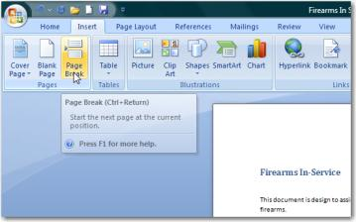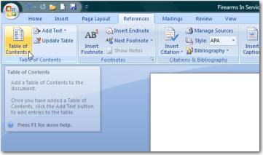
Table of Contents options are found on the References Tab, Table of Contents section

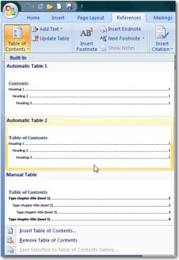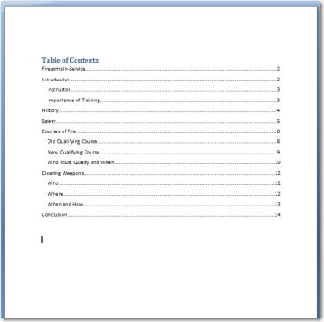
A Table of Contents is created, in place of the cursor, once a style is selected.
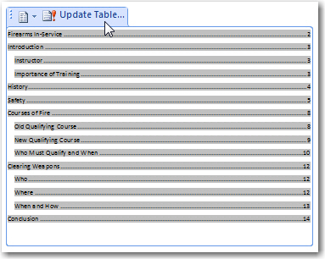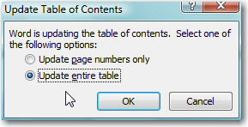
Right clicking a Table of Contents allows for the entire table to be updated or the page numbers only. Page numbers are automatically figured regardless of whether or not the document has numbers on the actual pages. Pressing F9 will also update the table.

Cover Page
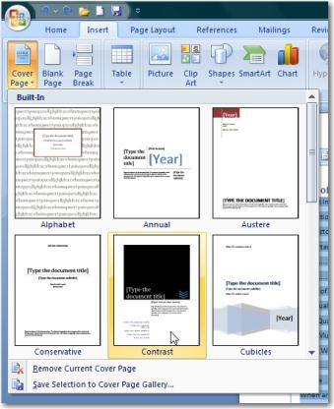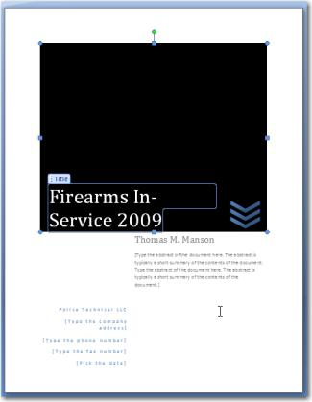
Cover Pages are found on the Insert Tab, Cover Page button. Several styles are available; many more are available for download.

Using PowerPoint®

Insert
A table can be inserted onto any slide using Insert tab.

Once the number of columns and rows are determined, the table can be formatted.

Table
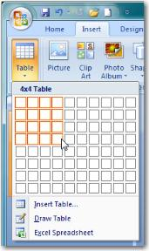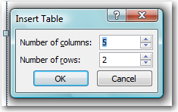

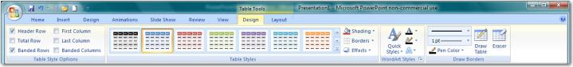

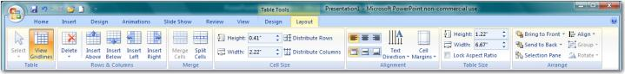

Picture
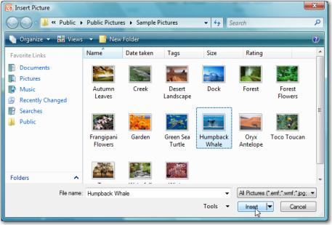
A picture can be inserted to any slide using Insert tab.

Once the image is inserted, the Format Picture toolbar will appear.

Several borders and coloring options are available.

Cropping is available on the far right of the toolbar.
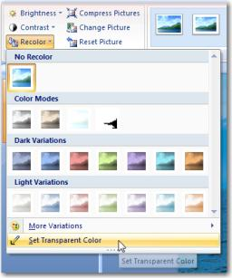
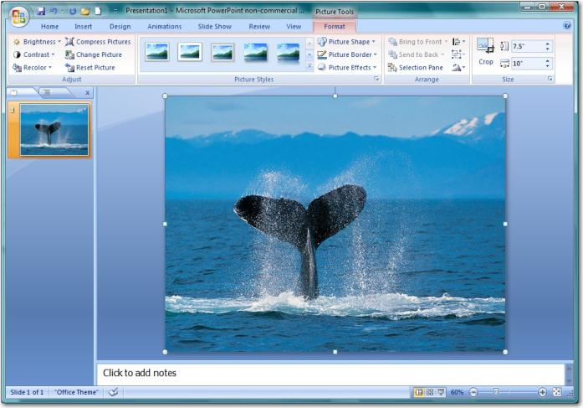
The Set Transparent Color Option is found under the Recolor drop down. This feature will allow the user to remove the background color from certain images.

Clip Art
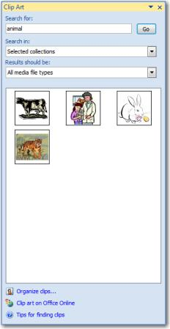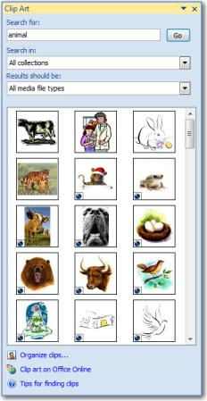
The Clip Art Gallery is keyword searchable and contains 100,000’s of royalty free, high quality images and pictures.

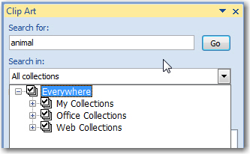
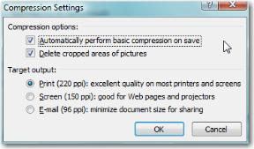
Quality settings for images can be set by the user. This can greatly reduce the size of PowerPoint® files.

Photo Album
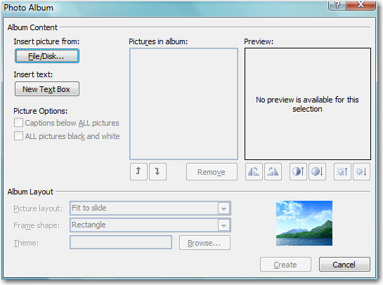
The Photo Album feature quickly inserts multiple images from a single directory (ie camera, folder, or other source).

Once a source is selected, all images can be chosen for insertion.
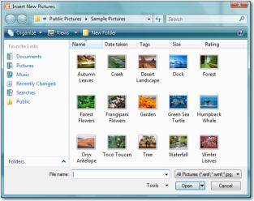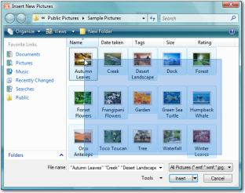
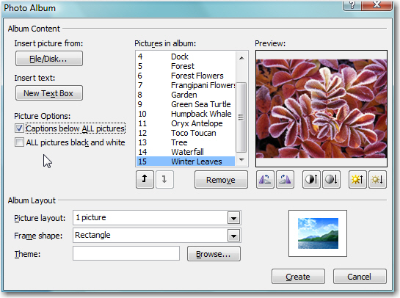
Selected images are shown in a preview window and can be adjusted using rotation, contrast, and brightness.

Album Layout provides framing options – including the number of images per slide and borders.

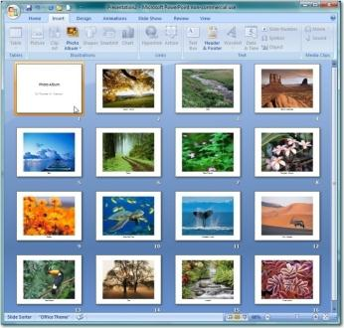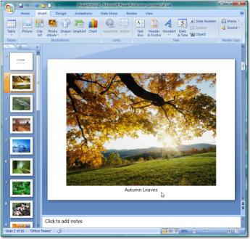

Shapes
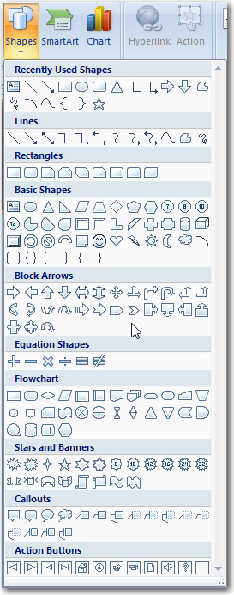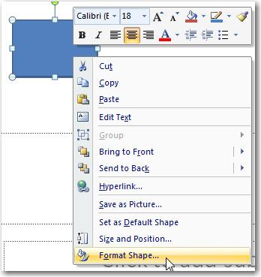
Simple shape changes (shade and border) can be affected using the pop-up menu.

Right clicking on a shape allows access to the Format Shape menu.
A variety of shapes can be added to any slide.

Shapes can be formatted by right clicking on a shape and selecting the option for Format Shape….
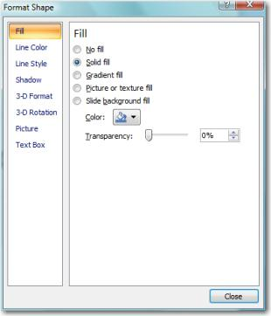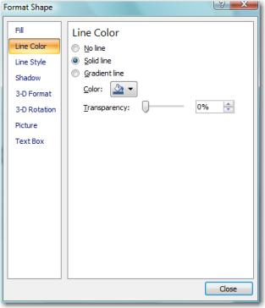
Format Shape options
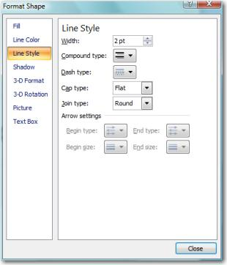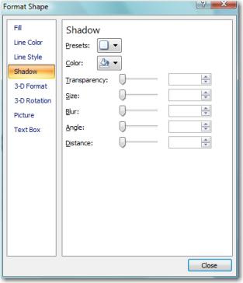
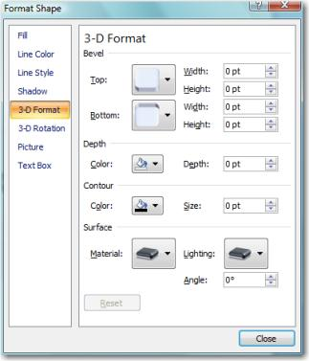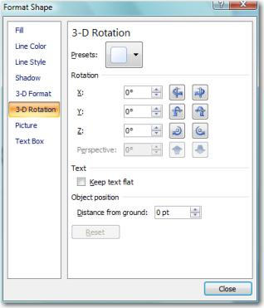
Format Shape options
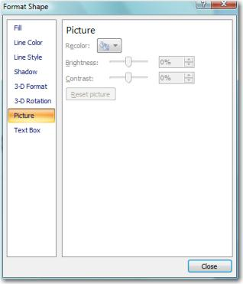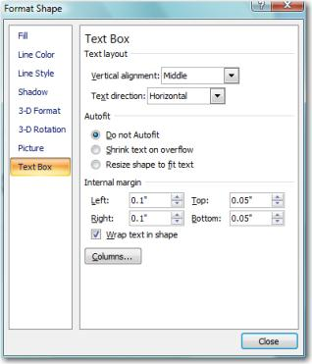
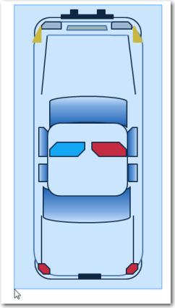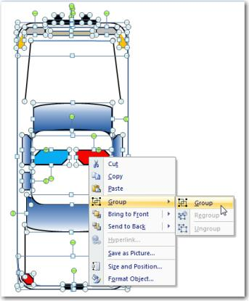
Multiple shapes can be “grouped” to make a unique object.

The new “object” can then be animated as a single object – such as the car example here.

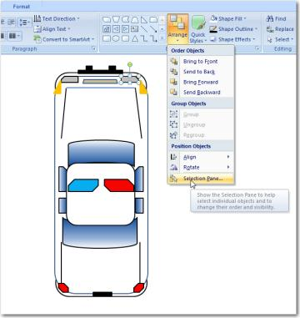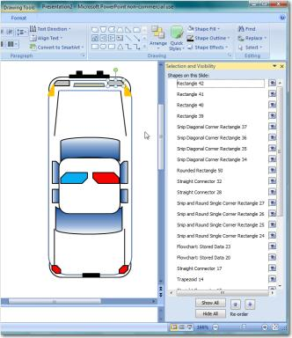
Objects on the screen can be “selected” and made “invisible” based on selections here.
The Selection Pane is found at the bottom of the Arrange drop-down menu.

SmartArt
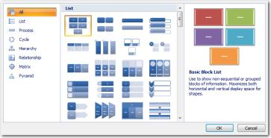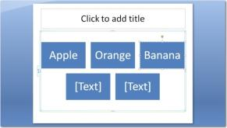

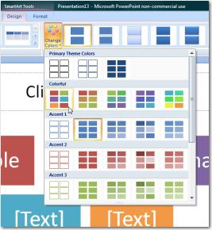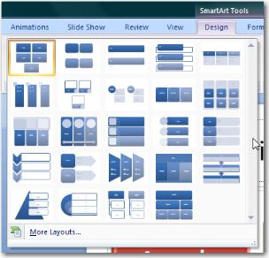
Smart Art graphics allow data to be presented in thousands of different formats.

Once a graphic is created it can be immediately altered.

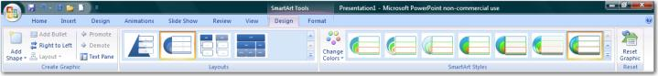

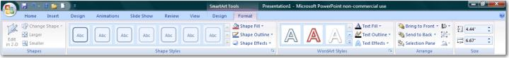
SmartArt Tools: Design and Format tabs

Chart
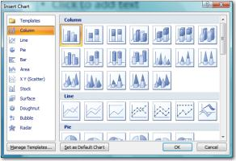
Charts, using Excel®, can be inserted onto any slide.

Users can select their chart style at the beginning of the process and adjust or change it later.

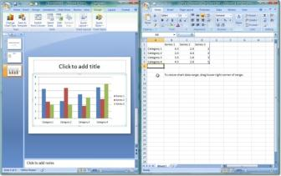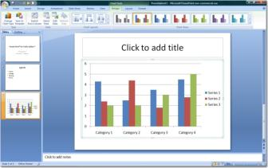

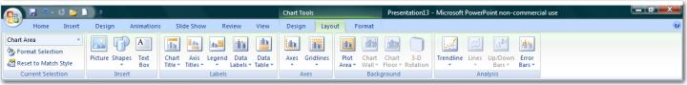

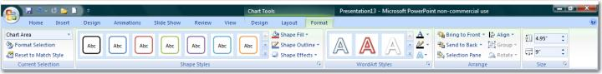
Chart Tools: Layout and Format tabs

Design Themes
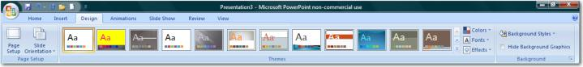
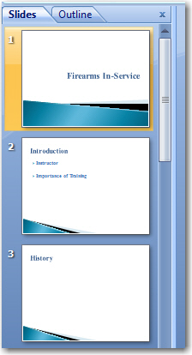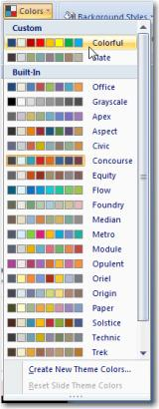
Design Themes are available from the Design tab.

A variety of stock Design Themes are available from the basic program, additional themes are downloadable.

Colors and backgrounds are among the changes users may select to alter Design Themes.

Users may also create and save their own unique Design Themes.

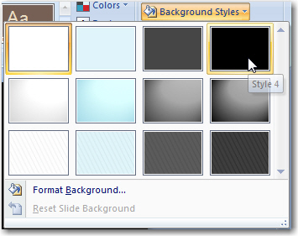
Background style changes are more subtle than changing an entire Design Theme.

Saving and Publish

Presentations
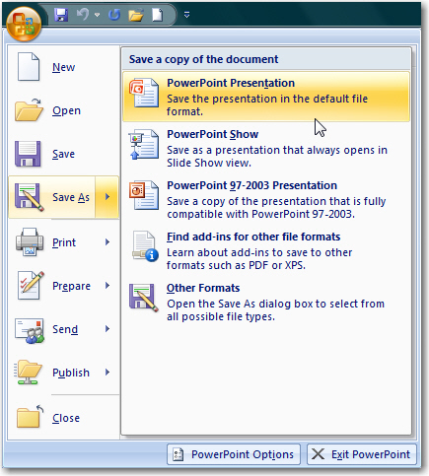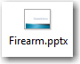
A presentation may be saved using the Microsoft button in the upper left hand corner, then Save As…

The first option is a PowerPoint Presentation.

Opening this file will open the “development” mode of PowerPoint®. All slides will be shown in addition to the standard toolbars of the program.

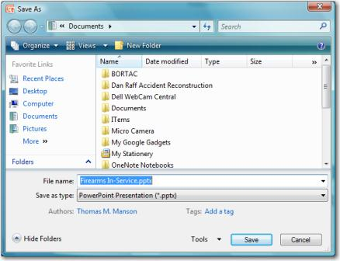

Shows
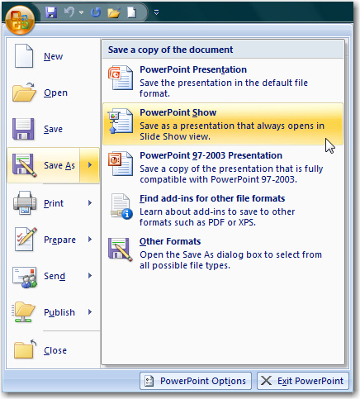
A presentation may be saved using the Microsoft button in the upper left hand corner, then Save As…

The second option is a PowerPoint Show.

Opening this file will immediately open the first slide of the presentation full screen. The “Development mode” of PowerPoint® will not be shown.
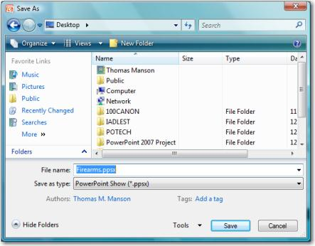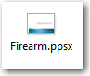

Other Options
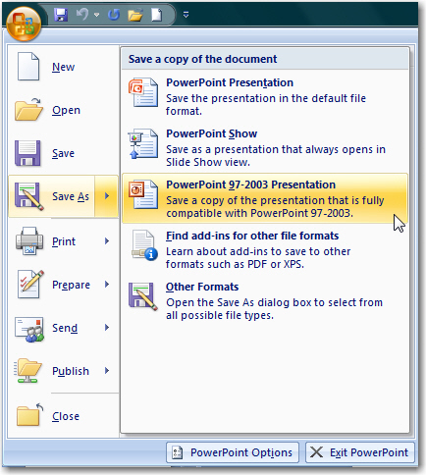
A presentation may be saved using the Microsoft button in the upper left hand corner, then Save As…

The third option is a PowerPoint 97-2003 Presentation.

Saving a PowerPoint® 2007 presentation in this manner will “flatten” or degrade all graphics created using 2007 tools. Changes will be indicated by the Compatibility Checker.

Note: Users should retain a PowerPoint® 2007 copy for future editing of any presentation downgraded into a PowerPoint® 97-2003 file.

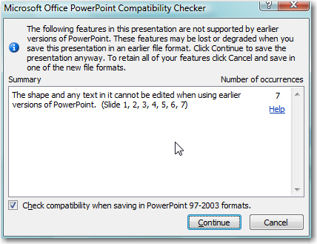
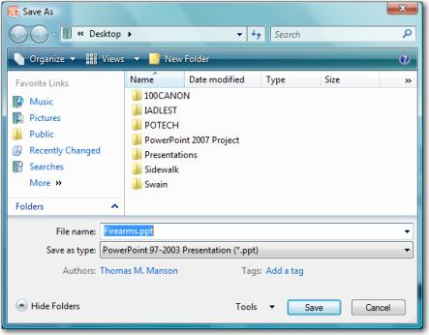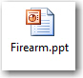
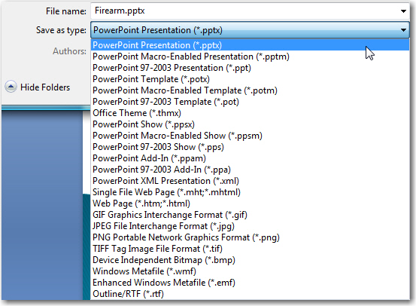
Numerous other file extensions are supported for saving a presentation including: Templates, Office Themes, XML presentations, and several graphics files.

Publish
Package for CD
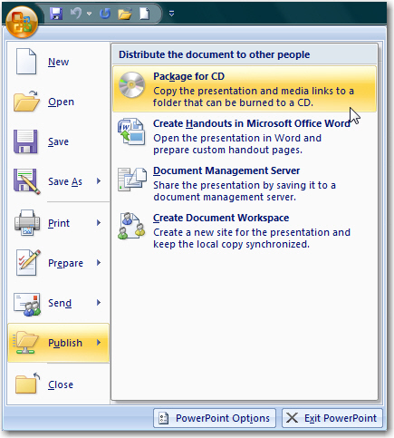
Package for CD creates a folder which includes:
- The original presentation
- All linked files (including videos, and other presentations)
- The PowerPoint® viewer, which allows the presentation to be run without a full installation of PowerPoint®.

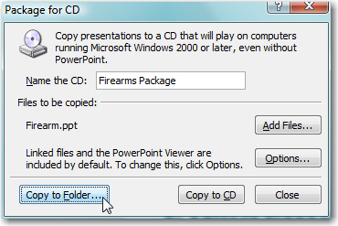
After naming the “CD” the presentation can be:
- Copied to a folder or
- Copied to a CD.

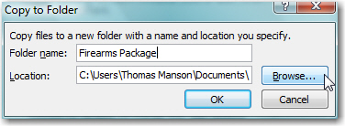
Copy to Folder options

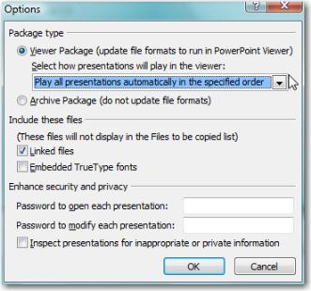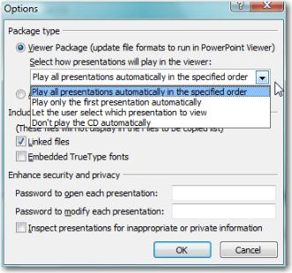
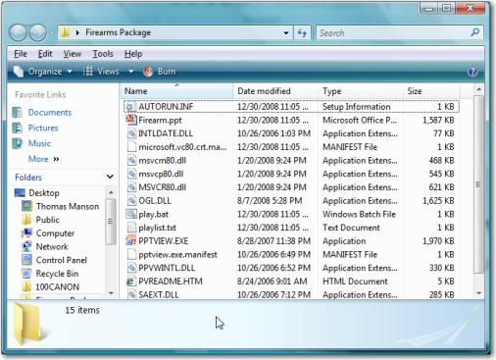
Files included the Package to CD feature.

Handouts in Microsoft Word®
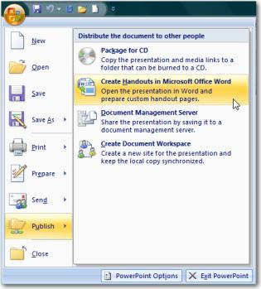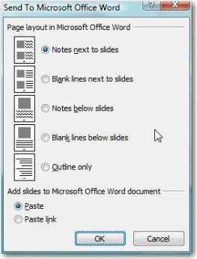
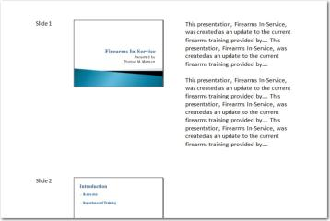
PowerPoint® can be “sent” back to WORD® using the “Create Handouts…” feature.

Options include:
Speakers notes next to slides, and
Outline only
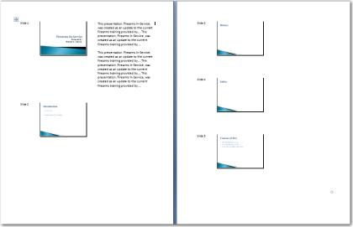

Security
PowerPoint® can be “sent” back to WORD® using the “Create Handouts…” feature.

Options include:
Speakers notes next to slides, and
Outline only
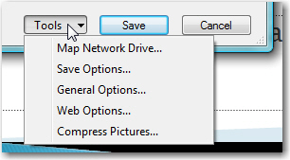
Security can be enabled from the Save As… window by selecting Tools, General Options….

Two level of security include:
Password to open
Password to Modify

Personal information (such as name and “company” information of the developer can be removed upon saving.
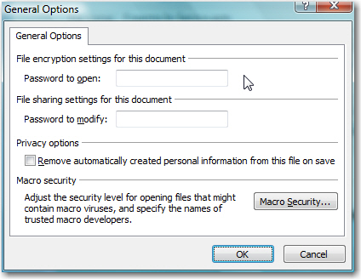

Printing Presentations
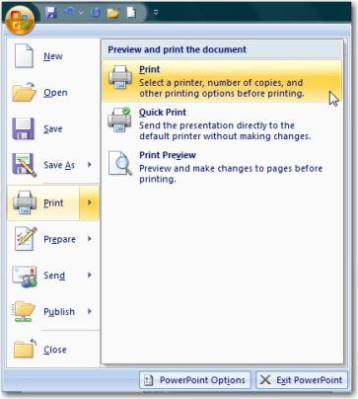

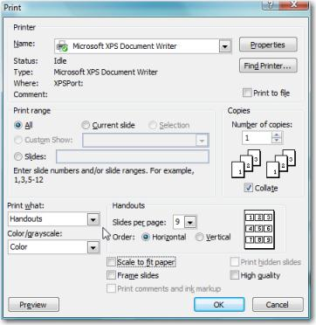

Hyperlinking

Rules of Hyperlinking
- PowerPoint® “sees” nearly everything on a slide as an “object”
  - This includes: Text boxes, pictures, clip art, et cetera.

- Any object can have an action setting or hyperlinks applied to it.

- To apply an action setting the object must be selected (e.g. have grab bars appearing)

- Have a legitimate reason for using action settings

- Make action setting simple

Action Buttons
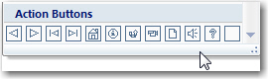
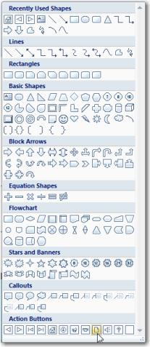

Action Settings
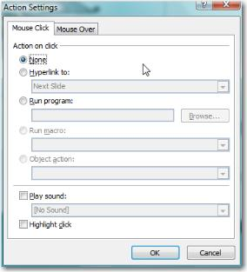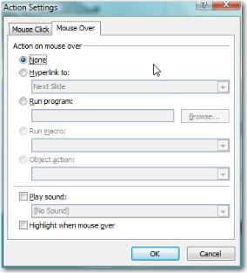

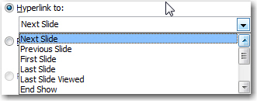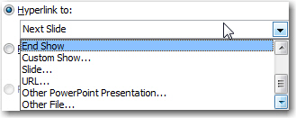
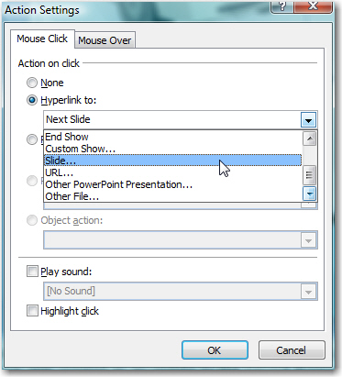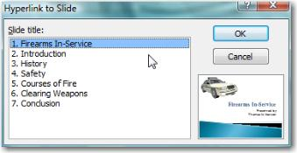

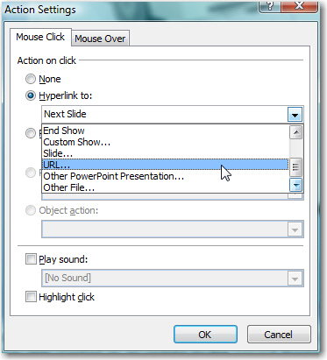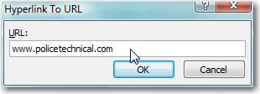
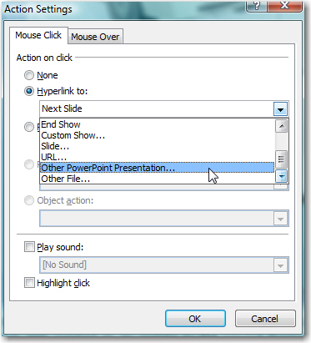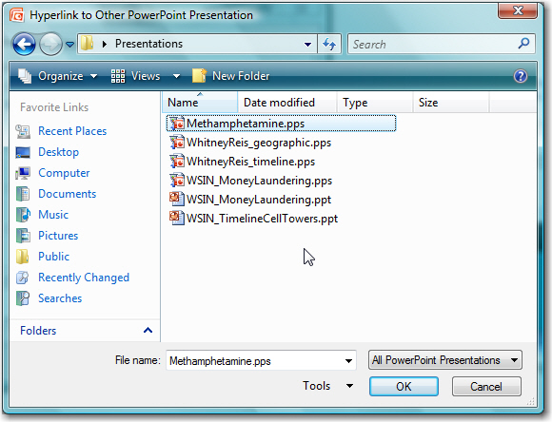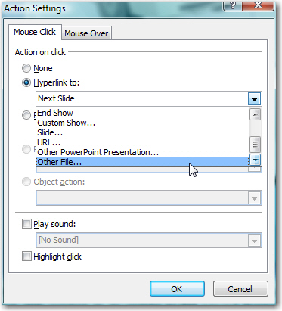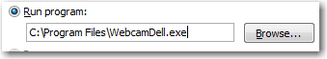
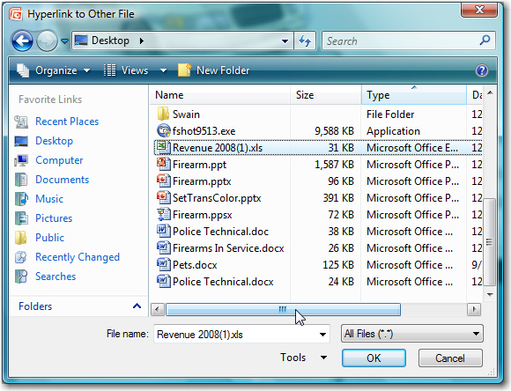
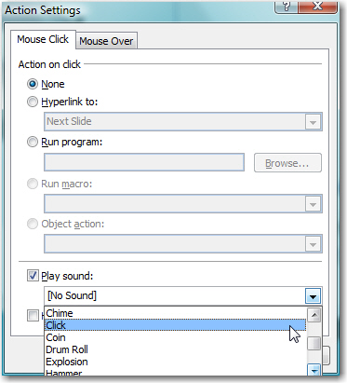
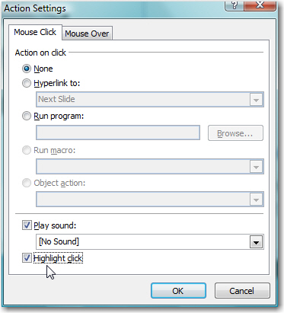

Hyperlinks
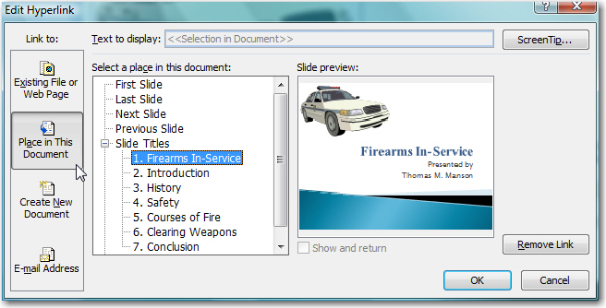
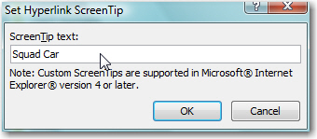

Creating a Splash Screen®
- Create your presentations
  - Gather them in one location (not required, but helpful)
- Create another presentation with a single slide
  - This will become your Splash Screen®
- Place a variety of shapes on the slide to serve as anchors
  - Use shapes (with text) instead of Text Boxes
  - Include additional shapes for future expansion
- Apply action settings to each shape
  - Hyperlink to “Other PowerPoint® Presentation…”
- Modify shape color and text
  - Two lines of at least ten characters are a good guide
- Save Splash Screen as a PowerPoint® show file (.ppsx)
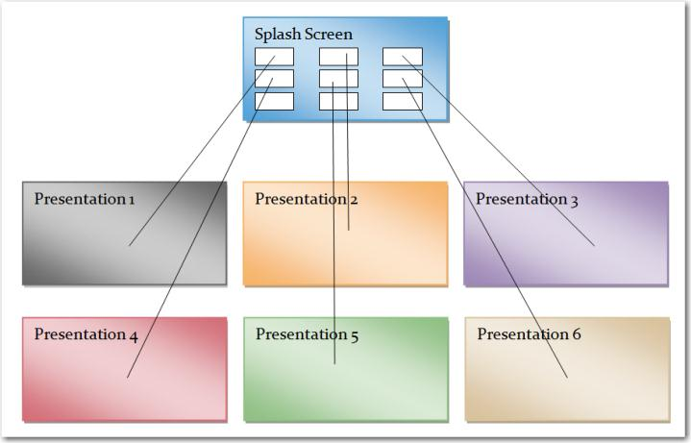
- Clicking the Splash Screen icon (XXXXX.ppsx) will activate the slide show.
- Clicking on a “hyperlinked” shape will cause that presentation to open.
- A presentation will close after its last slide (or with the ESC key) returning to the Splash Screen®
- Use of the ALT+TAB key will facilitate moving between presentations
- The Splash Screen® will close with the ESC key returning the user to the desktop.

Creating a Timeline
A different type of Splash Screen® the Timeline is a self-contained presentation that links to itself. In the example below the entire presentation is merely 5 slides long.
- Create slides representing each moment of time
  - This process is greatly aided with Microsoft Word©
  - Timelines can be of any period. Fractions of seconds to years.
- On any slide use lines or shapes to represent the timeline
- Place a variety of shapes near the timeline to serve as anchors, or use the timeline itself
  - One shape for each moment in time
  - Callout boxes work nicely, Line Callout 2
  - Text boxes can be added to enhance understanding
  - Terminators at opposite ends of the timeline help define the scale
- Apply action settings to each shape
  - Hyperlink to “Slide…”
- Copy “hyperlinked” timeline to each slide
- Modify shape color of timeline anchor on its corresponding slide
  - This helps the audience understand which moment on the timeline is being discussed
- A “Home” text box, linked to the first slide, placed on the Master slide, will assist with navigation
- Save file as a PowerPoint® show file (.ppsx)
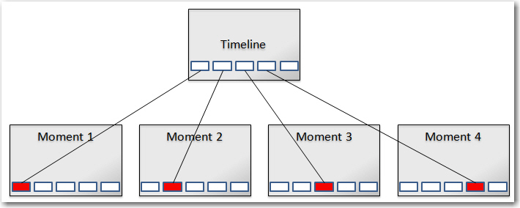
- Clicking the Splash Screen icon (XXXXX.ppsx) will activate the slide show, i.e. the timeline.
- Clicking on a “hyperlinked” shape will cause that slide to open.
- A presentation will close after its last slide or at any time with the ESC key

Games
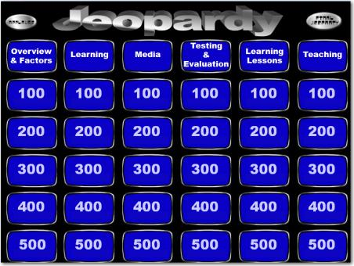
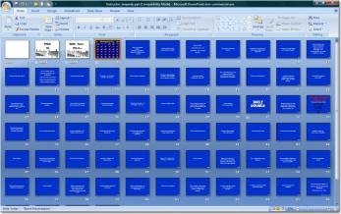
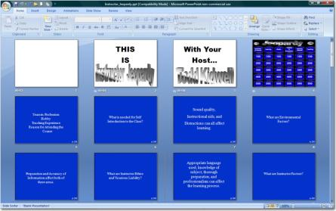

Promotional Package

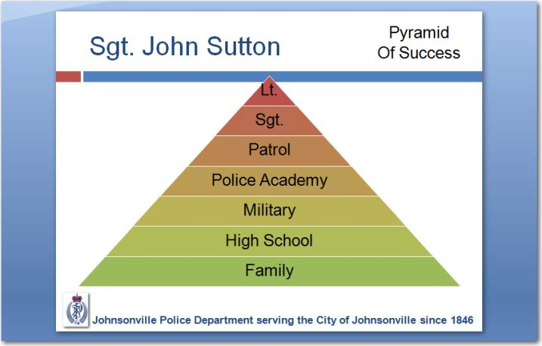
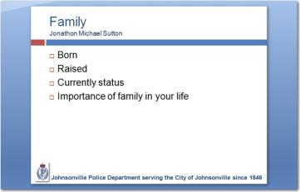

Animation

Transitions
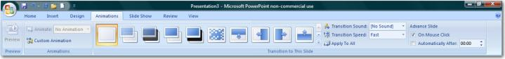

Animation through Transition
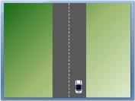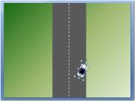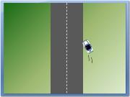

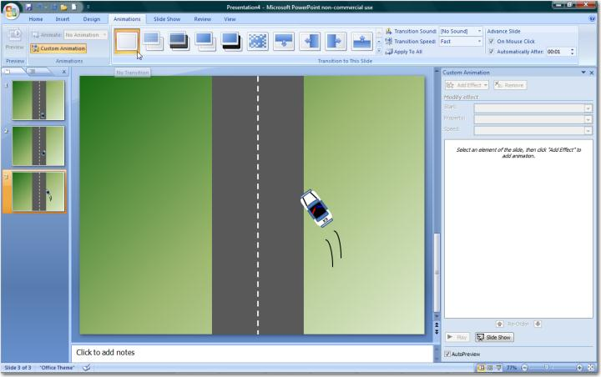

Stacking Order
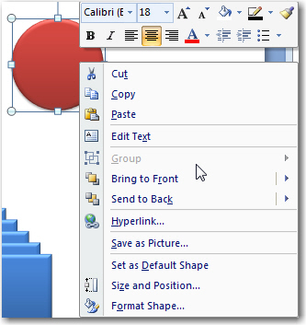

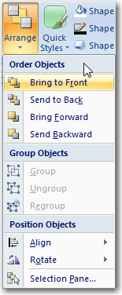

Selection and Visibility Tab
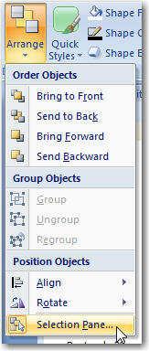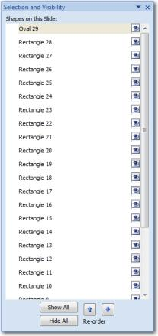
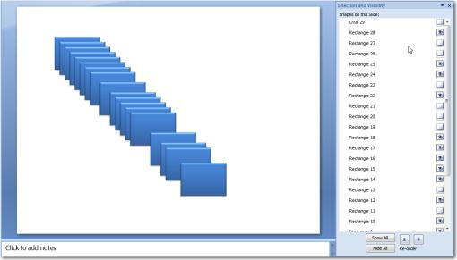

Custom Animation

Entrance
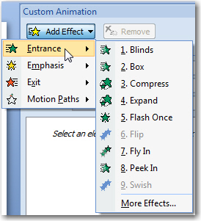
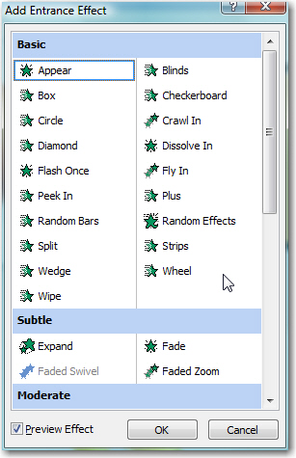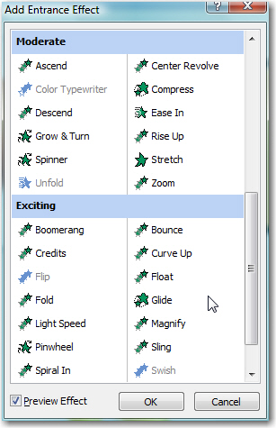

Emphasis
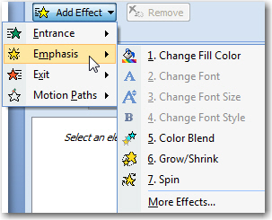

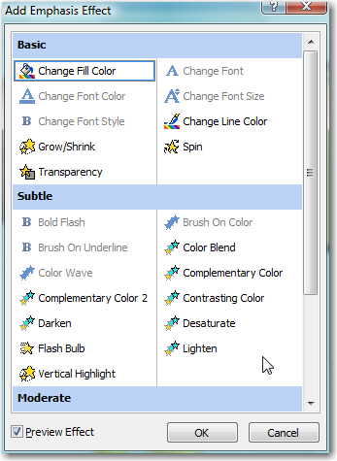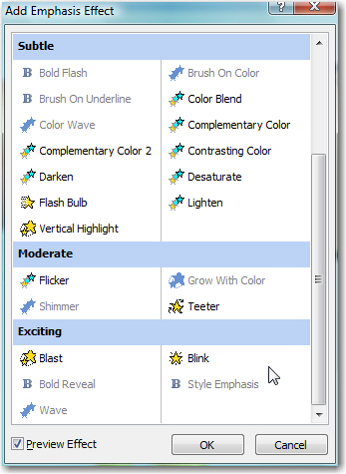

Exit

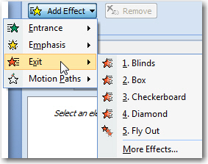

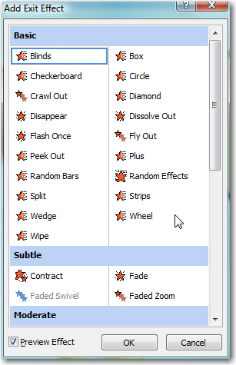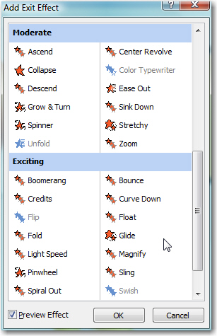

Motion Paths
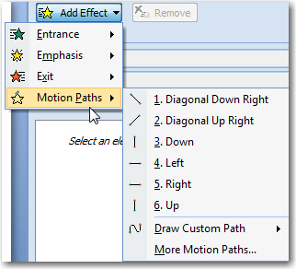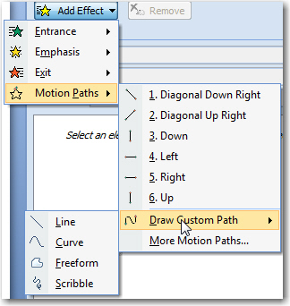

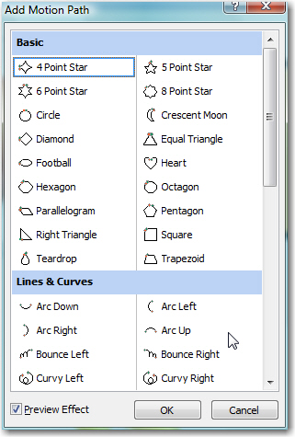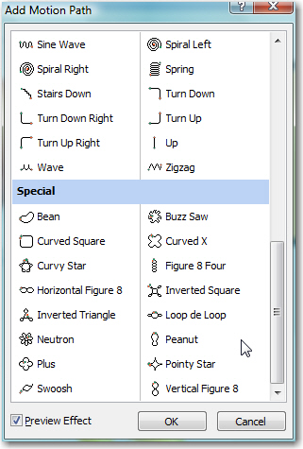

Effects and Timing
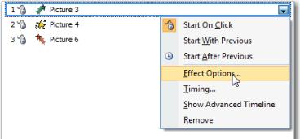
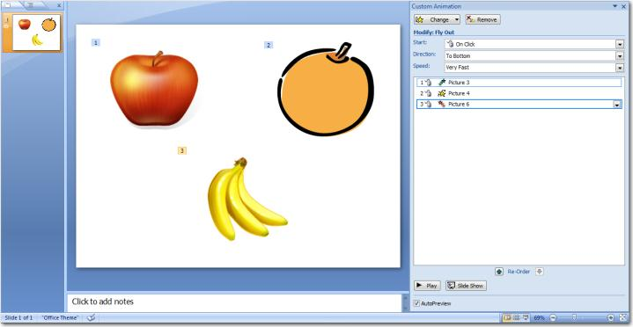

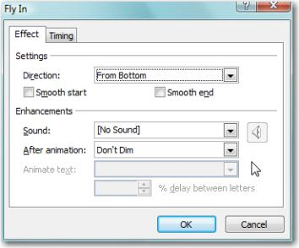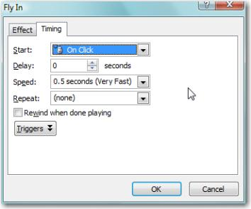

Advanced Timeline

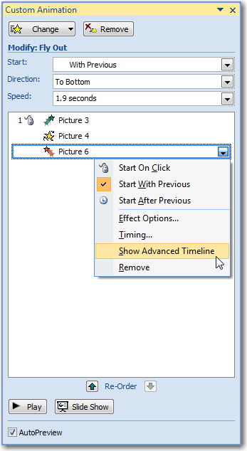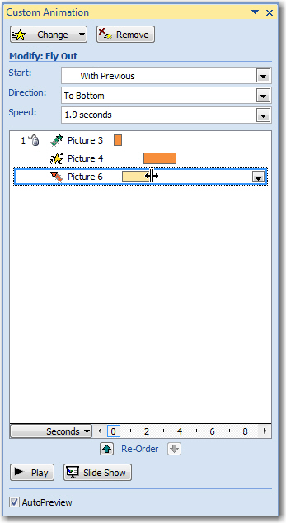

Animating Text

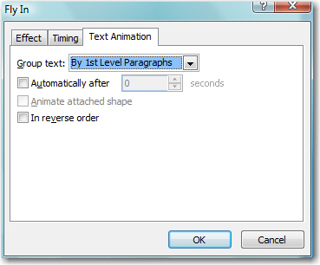
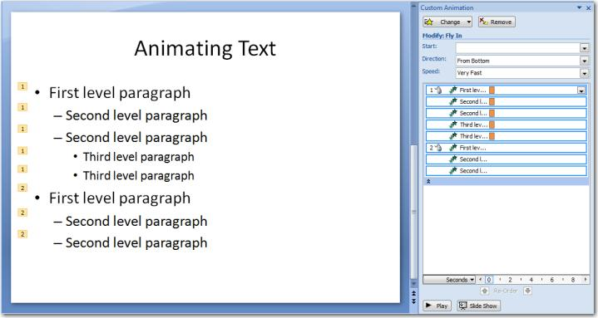

Diagramming Process

“Good, Fast, Cheap…Pick Two.” Guiding Principle of Custom Development

To create custom animations in PowerPoint® you need four things in place:
- A clear understanding of the process you wish to animate
  - If you can verbally describe it can likely be animated in PowerPoint®
- A clear understanding of the PowerPoint® custom animation principles
  - Understanding what PowerPoint® can and cannot do defines the project
- Time
  - The importance of the project and its frequency of use should determine how much time is devoted to a custom animation
  - If an animation will be used in the academy for the next 5 years it warrant spending 24 hours to perfect it; likewise a onetime use for an important court case.
- Patience
  - Animation will try the patience of most first time developers

The following three steps make developing animations in PowerPoint® more effective and time efficient:
- Talk out the process
  - With someone equally knowledgeable on the topic
  - Talk it out, out loud
- Sketch out the process
  - Using paper and pen
  - Draw out the process as you understand it
    - Story board
    - Single image
  - Use stick figures and simple shapes
  - Label major components
  - Note: If you cannot draw the animation, you should question if custom animation is the best option for the project. Video or pictures may be more effectively and quicker.
- Begin development in PowerPoint®
  - Resist the urge to skip steps 1 and 2.
  - The sketch is actually an outline which if created and used will
    - Greatly speed development
    - Increase accuracy of the final project

Animation Case Study – Vehicle
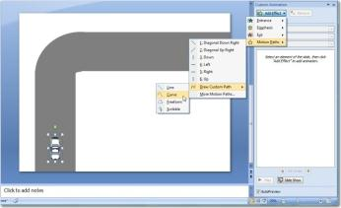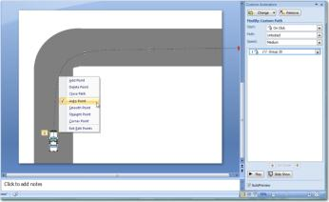

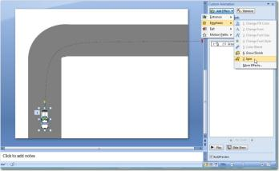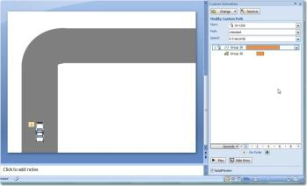

Audio

Adding a Soundtrack
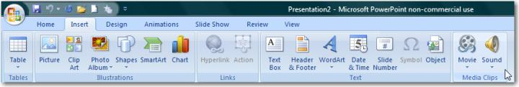
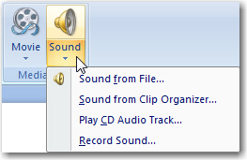
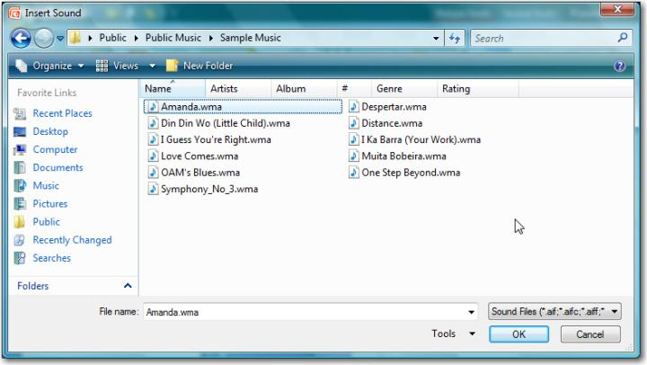
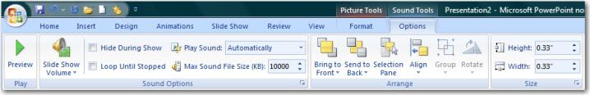

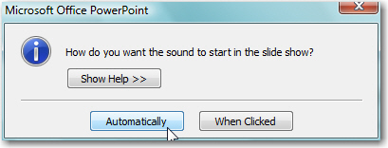
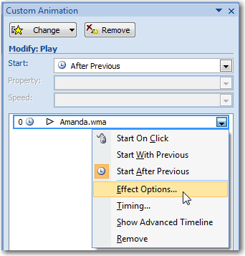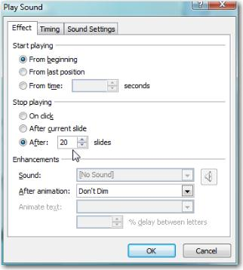
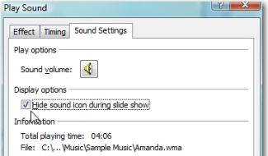

Record Narration
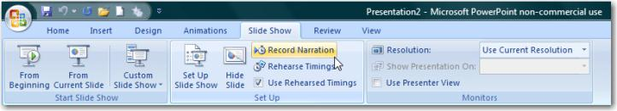
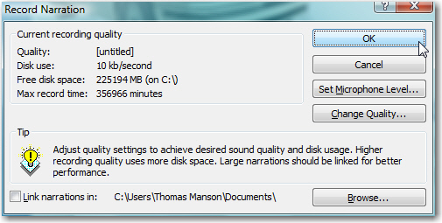
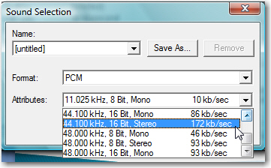

911 Recording and Text
The process for combining an audio tape with a transcript is
- Obtain a digital copy of the recording (.wav, .mp3)
- Obtain a digital copy of the transcript of the recording. (Microsoft Word®)
- Create a presentation from the transcript with no more than a few paragraphs per slides.
- Insert the audio file onto the first slide
  - Select to play automatically
- Make sound play for entire presentation
  - Either from Ribbon - Options Tab - “Play across slides”
  - Custom Animation – Effects - Stop playing after XX of slides
- Rehearse Timings from the Slide Show tab
  - Advance to the next as the transcript is “read” using the space bar
- F5 to test; save as ppsx.
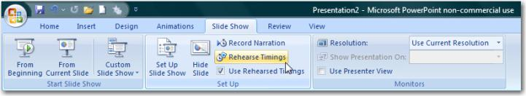
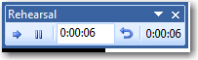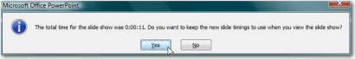
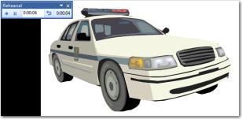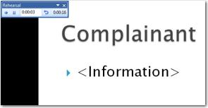
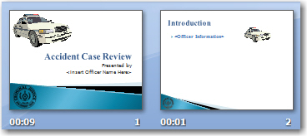

Video
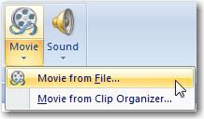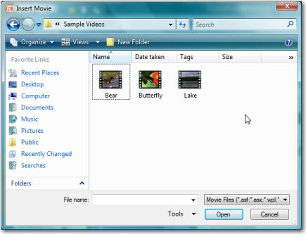
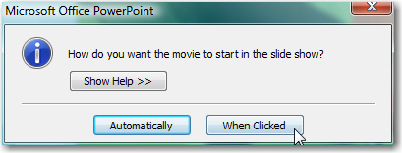

From the Internet

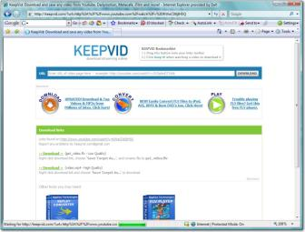

Camtasia
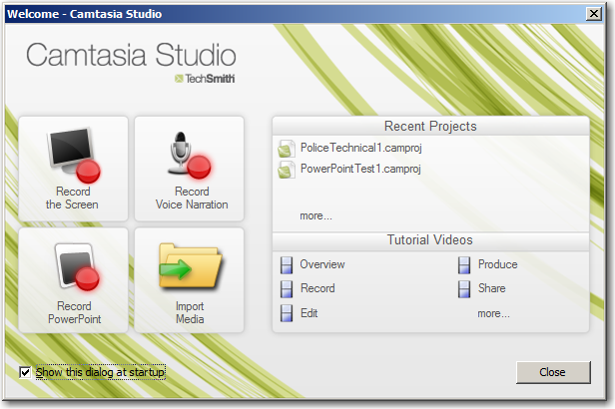

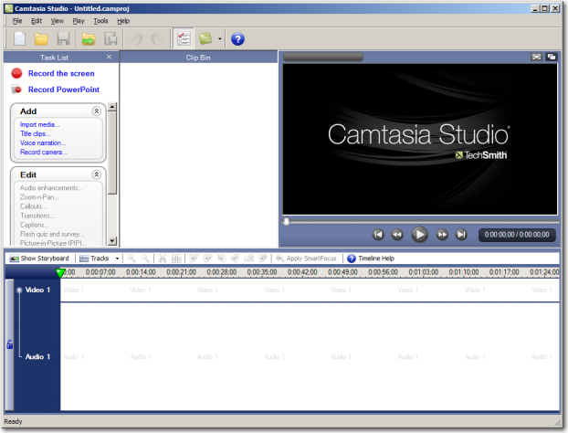
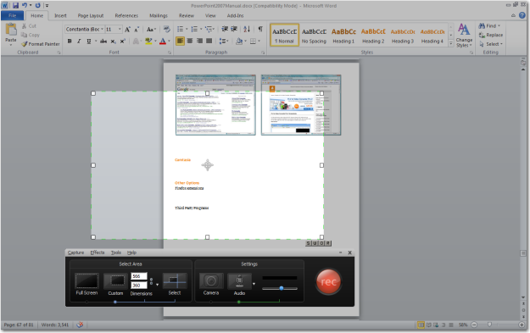

Other Options
Firefox extensions

Third Party Programs

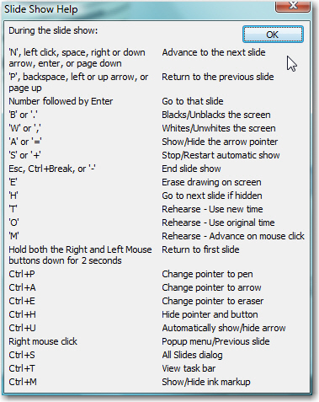
Keyboard Shortcuts
CTRL + Z Undo
CTRL + Y Redo
CTRL + B Bold On/Off
CTRL + X Cut
CTRL + C Copy
CTRL + V Paste
CTRL + M New Slide
CTRL + N New Presentation
CTRL + O Open dialog box
CTRL + S Save
CTRL + D Duplicate
CTRL + R Right justify text
CTRL + L Left justify text
CTRL + E Center text
CTRL + A Select all
CTRL + P Print dialog box

PowerPoint® 2007 Only
ALT + (another letter) Opens the entire ribbon for access
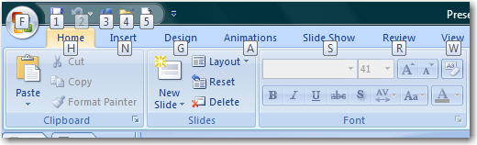

Autocorrect
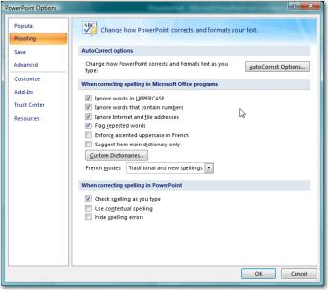

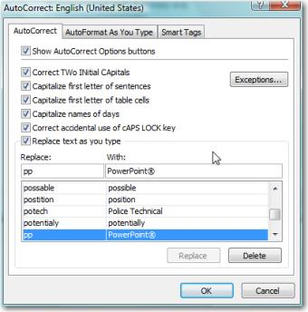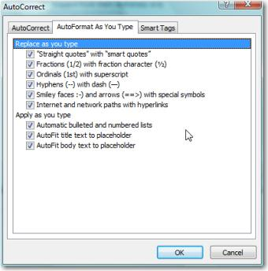

Master Slides
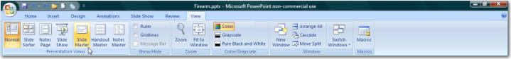
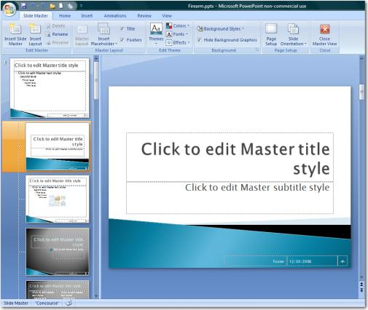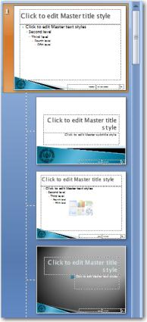

Templates
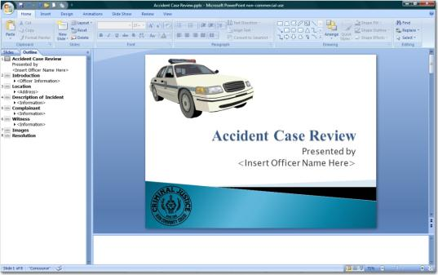

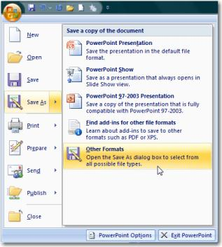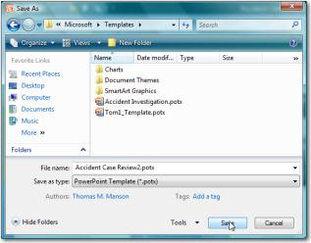

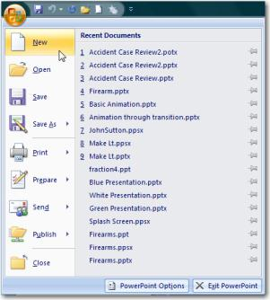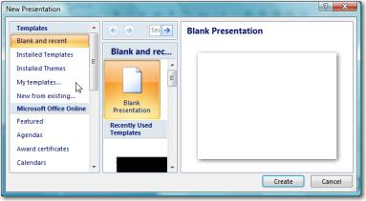

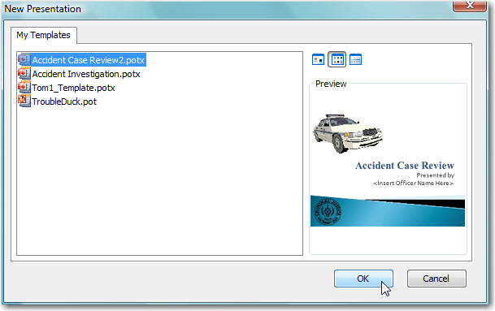

Presenters View
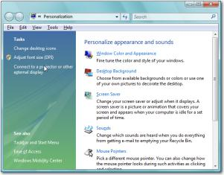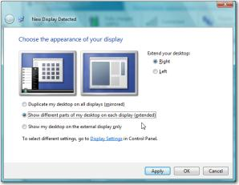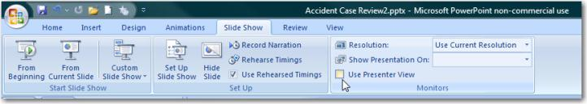

Review

Research
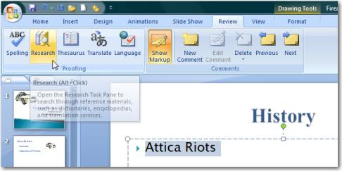
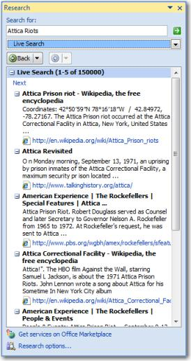

Translation
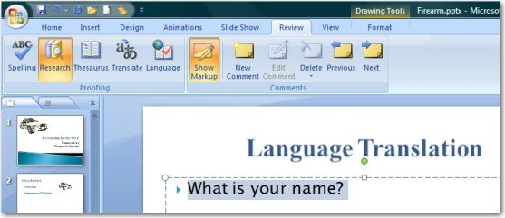
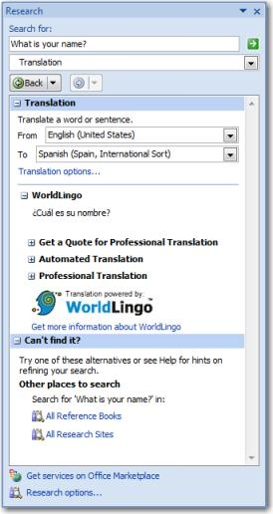

Comments
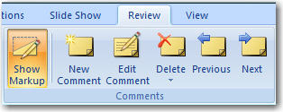
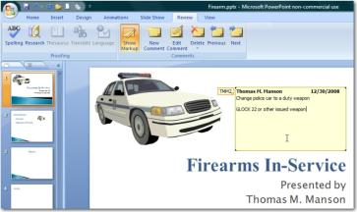

PowerPoint® Options
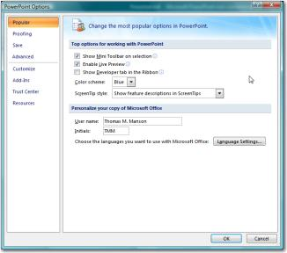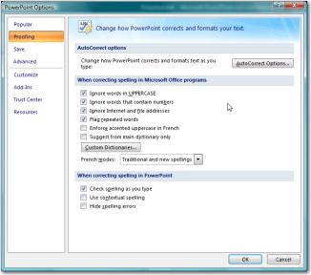
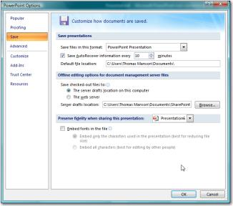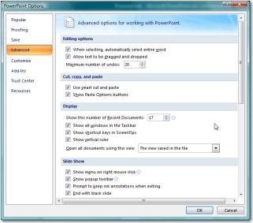
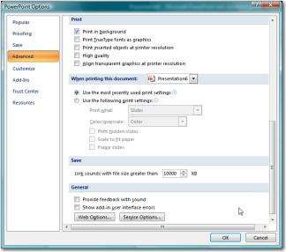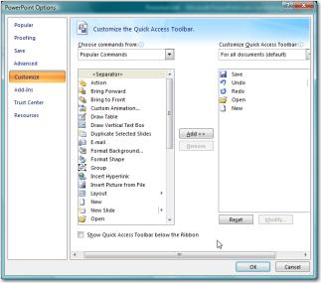
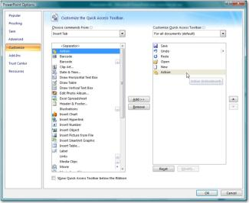

Cell Phone Investigations™ by Aaron Edens
Data from cell phones. Simply the most comprehensive course on cell phone examination and investigations. From the handset to the tower to the phone company to the courtroom.
Craigslist Investigations™ by Wayne Nichols
Methods and tools for successful Craigslist investigations. Case examples include property related crimes, drug investigations, prostitution, and enticement of juveniles.
Digital Forensics and Evidence Handling™ by Andrew E Neal
Data from devices. How the process works, how to handle digital evidence, what not to do, how to win in court, future directions, and building on your own in-house lab.
Excel® for Public Safety™ by Amy Kupiszewski
Harnessing the power of Microsoft Excel® to better manage data and improve investigations.
Telephone tolls, financials, arrest stats, fugitive lists and calls for service analyzed with a few clicks.
PowerPoint® for Public Safety™ by Thomas M. Manson
Designed to assist all personnel become more efficient and proficient with PowerPoint®
Faster development, internet videos, E911 audio, Splash Screens® and custom animation.
Social Media Methods™ by Doug Nolte
Designed to help departments and their personnel utilize social media effectively to manage their online presence; a prerequisite for any online investigation.
Visit www.policetechnical.com to view the national training calendar
Note: all national classes are two days in length, $350.00 per person, include manual, certificate of completion,
and access to additional downloadable material (when applicable)

Police Technical National Courses
Bring a Police Technical class to your agency
Police Technical has provided technical training to law enforcement since 1998
In-Service Training
An In-Service is the fastest, most cost effective way to provide technical training to your personnel.
We typically provide 2 days of training for up to 40 people at your facility.
An optional 3rd day of training for most classes offers students more hands-on time with the instructor.
Simplified pricing includes all expenses: Instructor fees, meals, travel, lodging, and training materials.
Contact our office for rates and scheduling:
812.232.4200 or at info@policetechnical.com

